AMB 200
Legacy Community Connect
Epic Hyperdrive 2026

WHA OB/GYN
Medical Assistant/Licensed Practical Nurse

AMB200 Table of Contents

Contents
Module 1: Signing in to Epic 3
Exercise 1: Open the Citrix Receiver 3
Exercise 2: Log into Hyperspace 4
Module 2: Gynecological Workflows 5
Exercise 1: Yearly Well Woman Exam – Est Wellness Visit 5
Exercise 2: Vaginal Discharge – Gyn Triage 29
Exercise 3: Dysuria – Established Office Visit 36
Exercise 4: Pre-Charting Well Woman Exam – WHA Wellness Visit 51
Module 3: Other Clinic Visits 53
Exercise 1: Abnormal Pap Smear – Colposcopy Procedure 53
Exercise 2: 8 Week Postpartum Visit with Mirena IUD Insertion – WHA Wellness Visit 62
Exercise 3: Clinic Administered Medication Documentation – Nurse Visit 71
Module 4: Obstetric Clinical Workflows 78
Exercise 1: 12 Week OB Visit – New OB Workup 78
Exercise 2: Return Prenatal Visit/NST Documentation – OB Check w/NST 90
Exercise 3: 3 Week Postpartum Visit 97
Module 5: Wrap Up 101
Tip sheets 101
Where to Find Additional Epic Resources 101

Module 1: Signing in to Epic

Exercise 1: Open the Citrix Receiver

Objective: To show learners how to access and login to the Epic Training system.
We will now log into the system and get started for the day.
In the clinic, you will click on the Legacy Apps icon on the desktop:

 - This is the default access to the system.

- Double-click the Legacy Apps icon.
- Then click Hyperspace ACE 1.
- Log in using the Fremont log-in located at the bottom left of your computer screen.

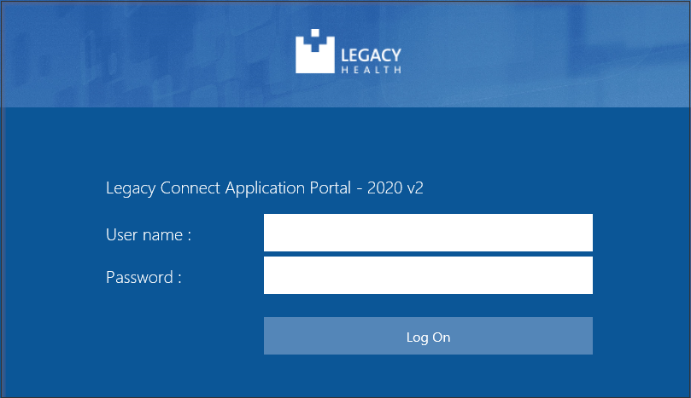

*Notice the moon icon  at the bottom right side of the login screen, if clicked it will change the background of the Epic login screen.

Exercise 2: Log into Hyperspace

Objective: To show learners how to understand and locate information specific for training.
Direct each learner to their Tent Card. Point out the User ID, Password, Departments, Patients and Providers.

Have new hires/students Login with their Tent Card information:
- User ID: WHAMA##
- Password: train
- Login Department: WHA TUALATIN [400147012]
- Message tip of the day; Click Ok

Module 2: Gynecological Workflows

Exercise 1: Yearly Well Woman Exam – Est Wellness Visit

Scenario: Gretchen is being seen today for a well woman exam, or what is also referred to as a wellness visit. I can see that Gretchen has Arrived for her appointment, so I will call her back (VERIFY it is the correct patient), log in to the exam room computer and begin documenting information for the visit.

First, single click the patient’s visit to highlight her appointment.

Review the Snapshot report in the Preview Pane.
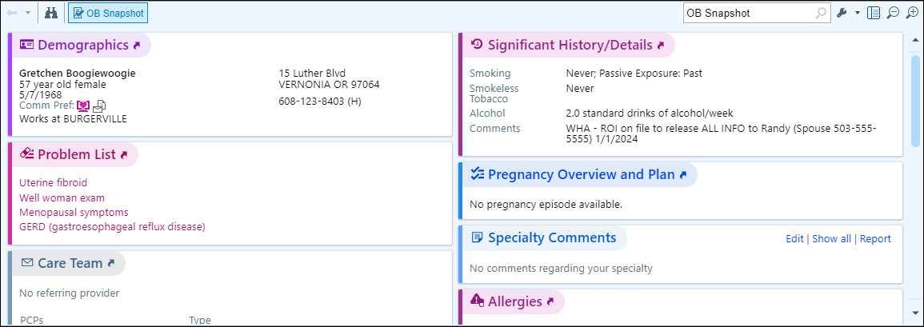

- Double-click to open the encounter for documentation.

Rooming Activity: 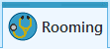

This activity is where you document the “intake” information for the patient.
Document the reason the patient is being seen today.

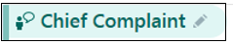

- Click Chief Complaint to open the section.

Notice there are preset speed buttons available to you. For this exercise, let’s explore the use of the search field to add reason for her visit.

- Click in the Add a new reason 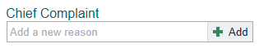 field
- Type: Wellness.
- Press Enter using your keyboard.
- Click Wellness Visit from the selection.

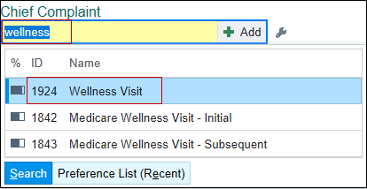

- Click Close at bottom of the activity.



Next, document the vitals that have been taken for the patient.

- Press Tab on the keyboard to quickly move between fields.
- Click on Vital Signs activity header or the New Reading button to open.

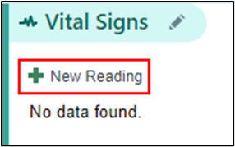

- BP: 116/74 (type 116 -space- 74) when you press tab to move to the next box, the system will input the /.
- BP Site: Click Left Arm button
- Patient Position during BP reading: click Sitting.
- BP Cuff size: click Adult.
- Heart rate: 68
- Temp: 98.6f
- Temp src: type Ty – for Tympanic.
- Weight: 134lbs – you must use units (lb or kg) to document the weight
- Height: 5f7 – you must use f for feet and/or i for inches.
- Resp: 14
- SpO2: 99

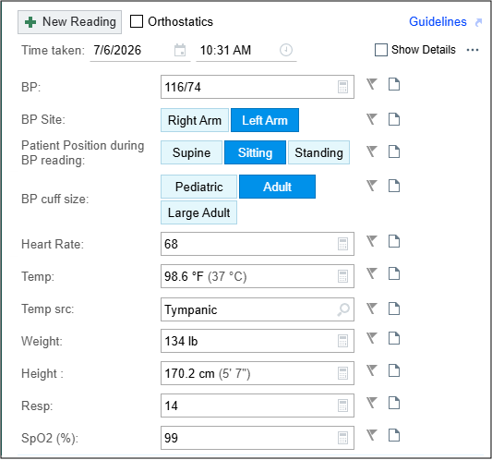

For Meaningful Use, you will want to verify Gretchen’s Tobacco Use as Never Smoker.

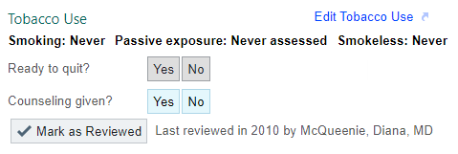

- Click Mark as Reviewed

Now you need to update Gretchen’s OB/GYN Status.

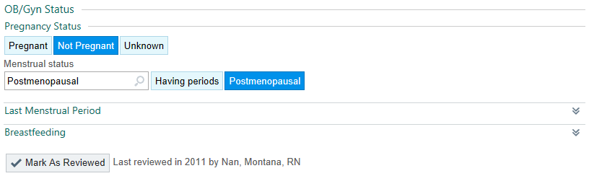
- Currently Pregnant? Not Pregnant
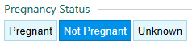
- Menstrual Status: Postmenopausal
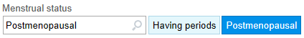
- Click the chevrons to expand the Last Menstrual Period section.
- LMP: Always verify Last Menstrual Period with patient

Gretchen verifies that this is the exact date for her LMP.

- Click the Exact button.
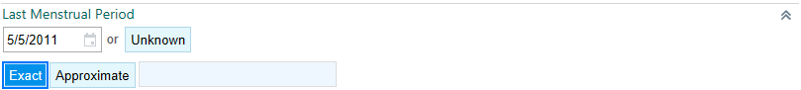
- Click the chevrons to expand the Breastfeeding section.
- Click Not Breastfeeding.
- Click Mark as Reviewed
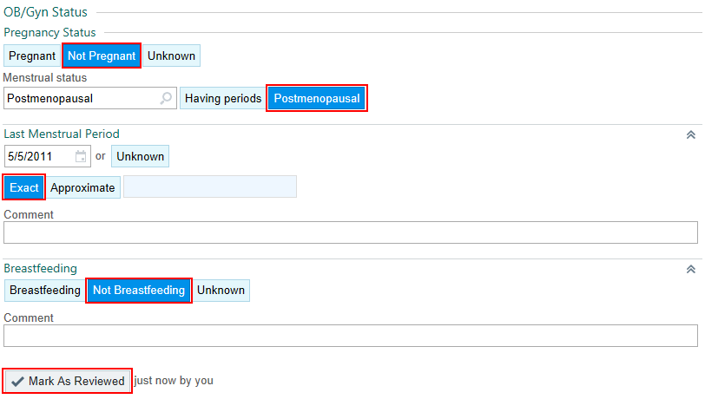
- Click Close.



- Click the pencil or the New Reading button.

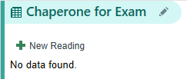

- Verify with the patient whether she would like to have a chaperone for her visit and click the corresponding button.

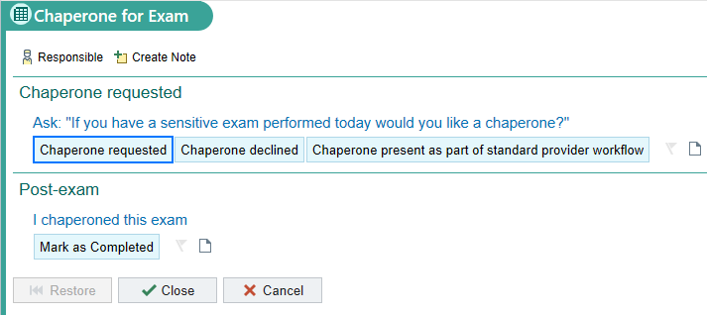

Gretchen has declined a chaperone be present for her visit.

- Click the Chaperone Declined button.
- Skip the Post-exam section and click Close.


Your patient is Postmenopausal and status post (s/p) Supracervical Hysterectomy, do you need to update this section? No.

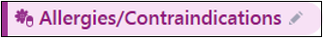

Verify that Gretchen’s Allergy list is correct and that she still has No Known Drug Allergies (NKDA).

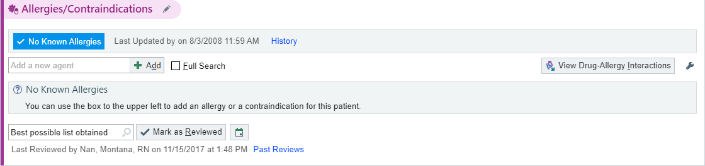
- Click the Mark as Reviewed 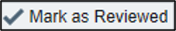 button.

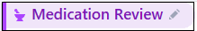

Gretchen states she is taking one new medication. She picks up her regular prescriptions at Silverton Pill Box on 302 N. First Street, Silverton Oregon and her compounding prescription at Lloyd Center Compounding Pharmacy 2606 NE Broadway St, Portland Oregon
- Click the Medication Review activity header to open it.
- Verify both Pharmacies are correct by clicking the pharmacy hyperlink under the Medication Review activity.

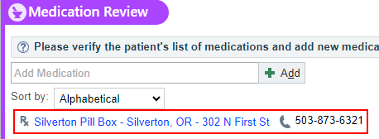

**Note: You will need to manually adjust the destination of the order if it is not being sent to the Silverton Pill Box, as it is currently set as the default pharmacy.**
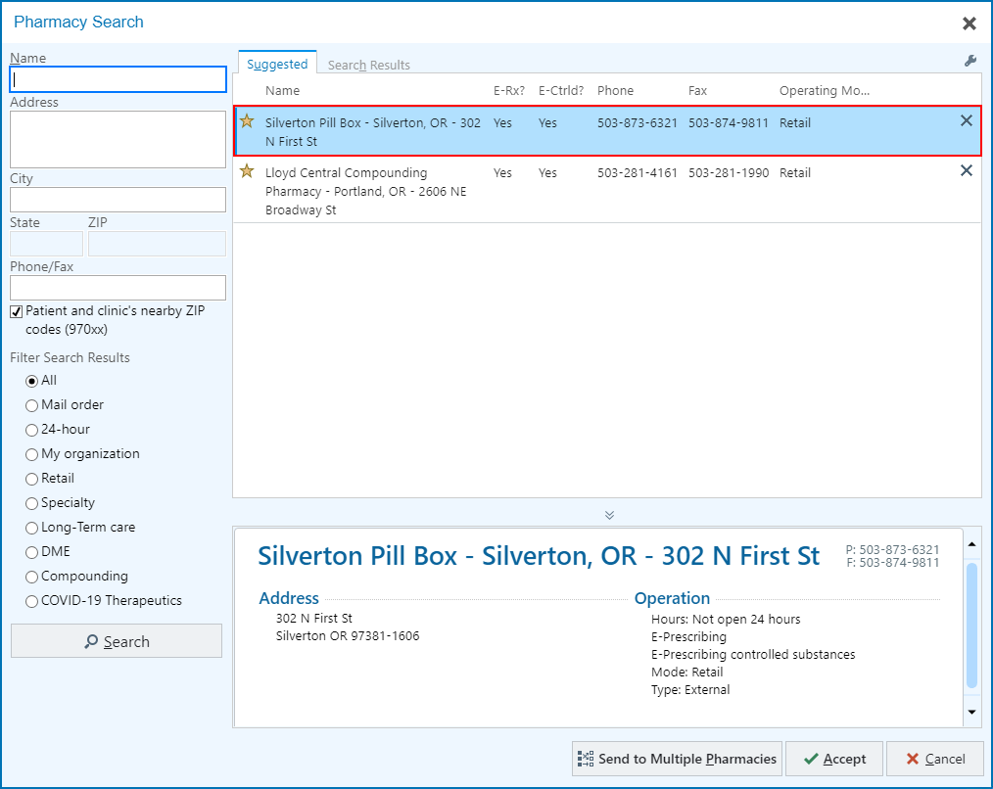

Gretchen says she is currently taking all the medications on her list.

- Mark Taking on the compound medication, multivitamin, omeprazole, and vitamin D3 OR select the Mark Unselected Taking button.

Let’s update Gretchen's medication list to include Allegra, which she will now be using as needed for her seasonal allergies.

- Go to Add Medication.
- Type: Allegra.
- Click Add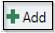 or press Enter.

A Select a Medication window opens and displays medications found on the Preference List.

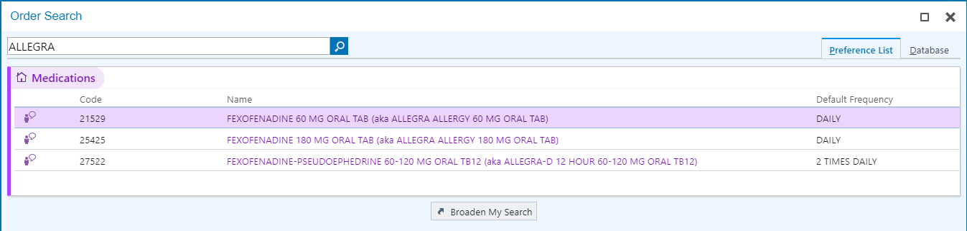
You may only see the generic names for Allegra.
- To find all choices, click Database or Broaden My Search .
- Using your mouse, double click on Allegra 60 MG ORAL TAB to select.
- Change the Frequency from Daily to PRN. Type PRN in the Frequency

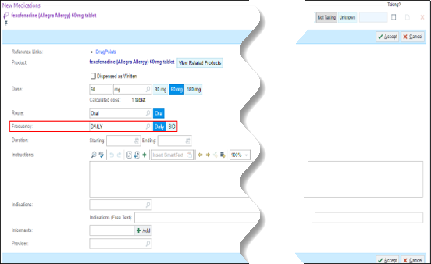

- Double click PRN.

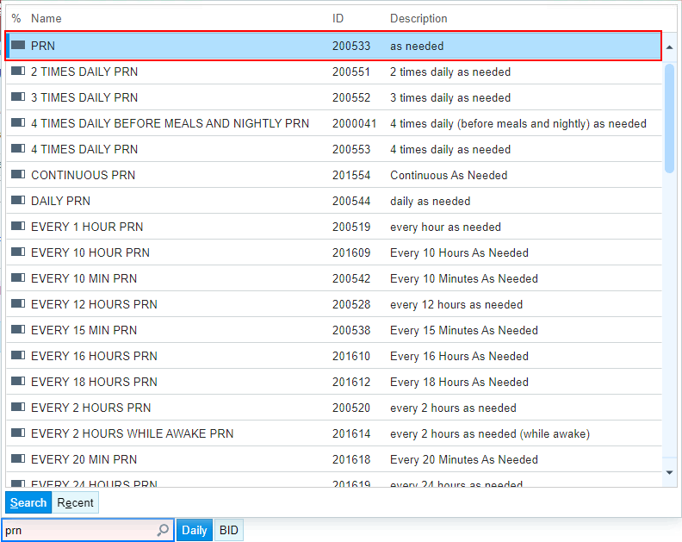

- A Yield sign will appear. Check the Other box.

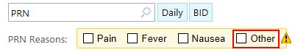
- In the PRN Comment box type: seasonal allergies.

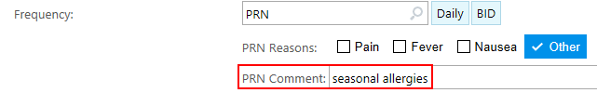

- Click Accept to save the changes made to the medication.
- Mark the Allegra as Taking.

- To update the Med List Status, click the down facing arrow.
- Select: Best possible list obtained.

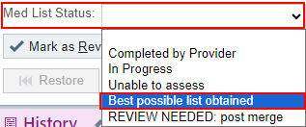
- Click the Mark as Reviewed 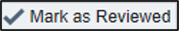 button.
- Click Close.

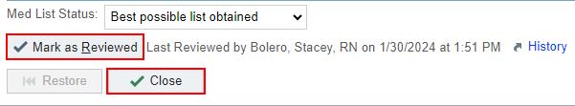

Gretchen states that her sister was recently diagnosed with Type 2 Diabetes that is diet-controlled, so you will need to update that under the Family History section.

- Click the History activity header to open the activity.
OB History

- Confirm that Gretchen was Never pregnant and that the appropriate box is selected.

Medical History

- Scroll down to the Medical History section.
- To minimize the Quick entry section, click the Chevrons on the right side of the activity.
- Confirm that no changes need to be made to her Past Medical History.

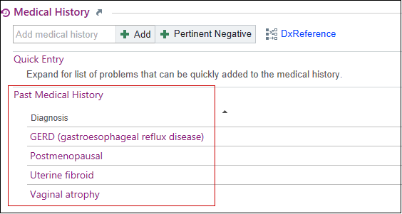

Gynecology History

Gretchen states she started having her periods at age 11. She’s never been pregnant. She was considered postmenopausal as of her last period, so we also know her age of menopause. The other boxes do not apply to her, so they’ll be left blank.

- Age at Menarche: 11
- Age at Menopause: 49

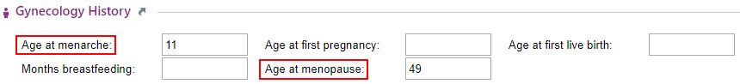
Surgical History

- Scroll down to the Surgical History.
- Click the Chevrons in this Quick entry section as well, to minimize it to be able to see the patient’s previous surgeries.

Gretchen confirms that no changes need to be made in her Past Surgical History.

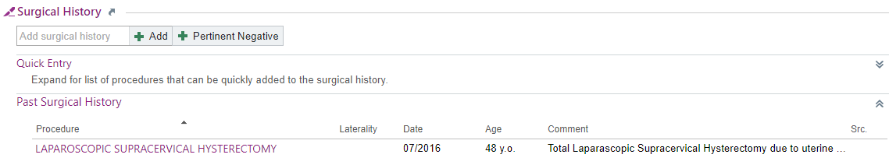

Family History
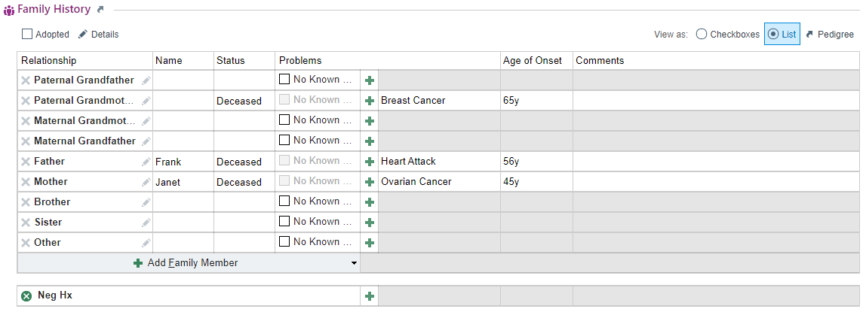

- Scroll to the Family History section.
- Add a name for Gretchen’s sister: Gertrude.
- Add a Status: Alive.
- Click the Green +  to add a problem for her Sister.

- Type diabetes.
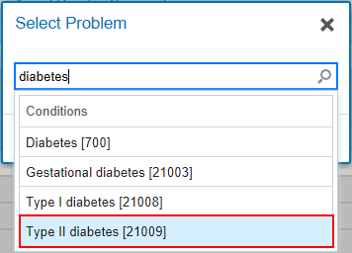

- Select Type II diabetes.
- Type 68 into the Age of Onset column.

Now let’s add a comment to Gertrude’s diabetes diagnosis.

- Click in the Comment column next to Age of Onset to add the comment: “Diet controlled”.
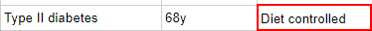

Sexual Activity

You must review with Gretchen that she is still sexually active with male(s) and ask if she has had any new partners since her last Wellness Visit. Confirm she was Postmenopausal at the time of her Supracervical Hysterectomy.

- Verify she is still sexually active with Male partners.
- Confirm Post-menopausal and None boxes are checked.

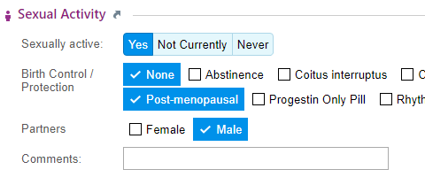

Alcohol
Gretchen confirms that she usually has 2 glasses of wine per week.

- Verify it is documented that patient reports 2 glasses of wine per week.
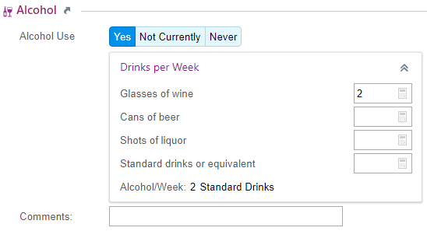

Drug Use

Gretchen verifies she has no history of drug use, currently or ever.

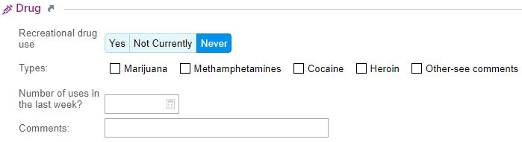

Tobacco
You reviewed her tobacco use in the Vitals section. Do you need to update this here? Yes, this is a good place to document Passive exposure to tobacco.

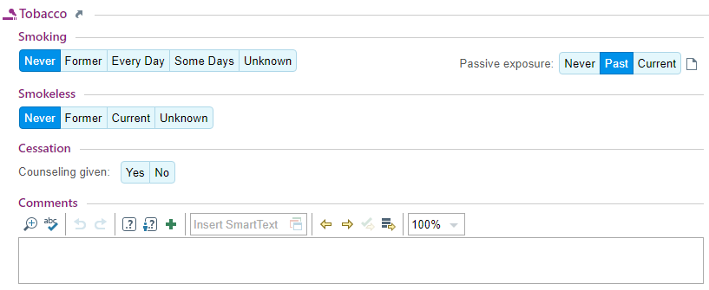

Vaping Use
Gretchen confirms she has never used a vape.

- Document no vaping use, currently or ever by clicking Never Used .

The rest of the Vaping sections can be skipped because Gretchen reports never using a Vape. Scroll down to Sexual History.

Sexual/Social History

Gretchen confirms no changes are needed and that she has never used any drugs, including any that were injected or used with needles.

- Click No on the unanswered question “Used drugs that were injected or used with needles?”

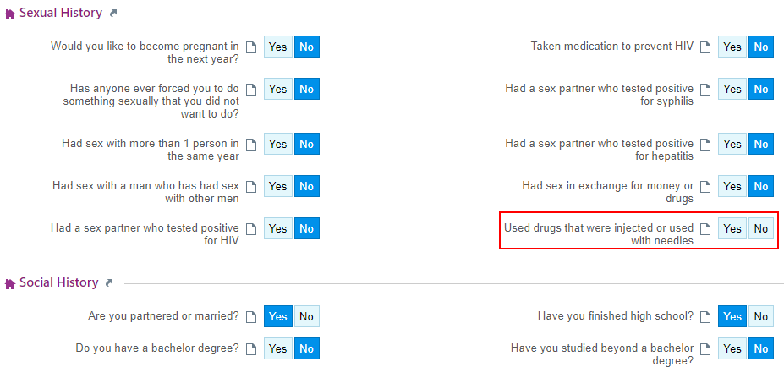

Social Documentation
Gretchen confirms no changes to this section.
- Click the Mark as Reviewed button. .
- Click Close.

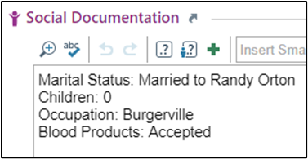

Now, we need to document Gretchen’s PHQ Depression Screening and her Breast Cancer Risk Assessment. To do that we need to go into the Screenings activity.

Screenings Activity: 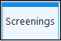

- Click on the Screenings activity tab to open section.

! Important: this hyperlink is not functional within the training environment; please proceed by skipping this section when completing the exercise.

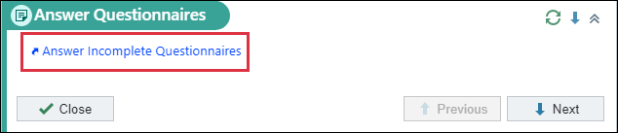

- Click Close.



- Click on the Breast Cancer Risk Assessment tab.
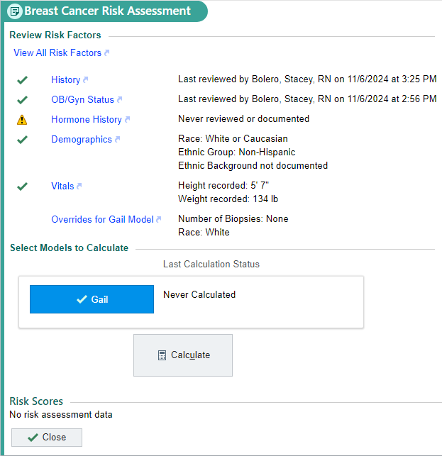
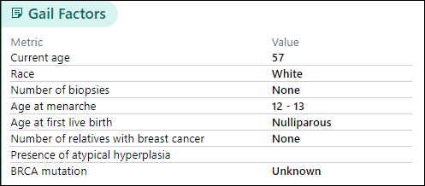

Gretchen verifies that she has not had any breast biopsies or breast surgeries, so no changes need to be made to her history.

- Click Calculate 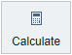 once the View All Risk Factors report has been reviewed.
- Once a score populates, click Close.

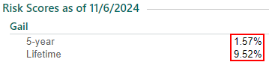

Progress Notes Activity: 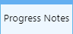

The note is mostly complete as it is constructed incrementally during the patient’s appointment.

There are several features that streamline documentation. First, there are templates available for me to start my note.

- On the far right of your screen you will see a small blue button.
- Click Open Sidebar.
- Click the drop-down arrow next to the Create Note button to open the list of WHA Note templates.
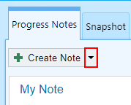
- Select WHA Wellness Visit.
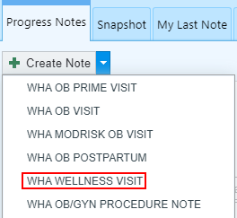

Notice that the template auto-populates the information you entered during the rooming process.
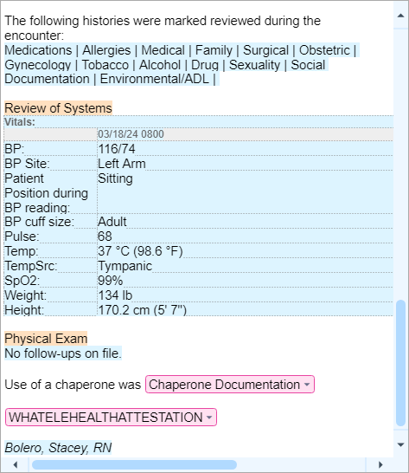

- In the Note place your cursor next to “History of Present Illness:”.
- Press Enter on your keyboard.
- Type: .WHAHPIWWE5065
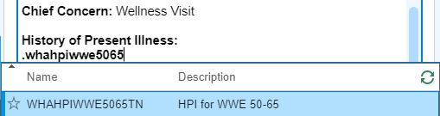
- Select the smartphrase you need, then press Enter on your keyboard or double click on the desired smartphrase.
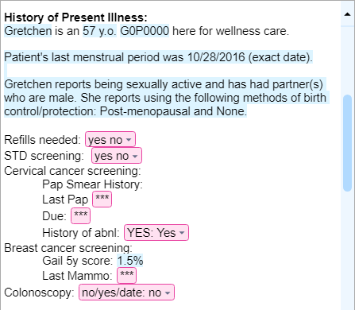
Press F2 to have the system find the variables for you. F2 through all the wildcards to complete the documentation.

- Select the variables within the SmartPhrase to complete your documentation.
- You may chose any answer from the list.
- Utilize the Assistant Search bar in the Hyperspace toolbar, Chart Review, or Care Gaps to fill in the historical medical information such as the patient’s last Pap smear, last mammogram, and colonoscopy.
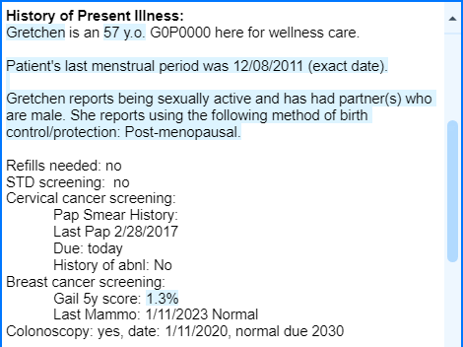

Now that you have completed documenting the “intake” for the patient, it is time to continue with the specific scenario.

Orders Activity: 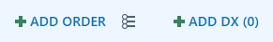

Now, you will place an order for a Pap smear using the Preference List.

- In the visit taskbar at the bottom left of the screen, click the Preference List button, located between the Add Order and Add Dx buttons.
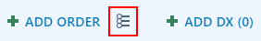
- Click the arrow next to Labs in the Navigator on the left side.
- Click Pathology.

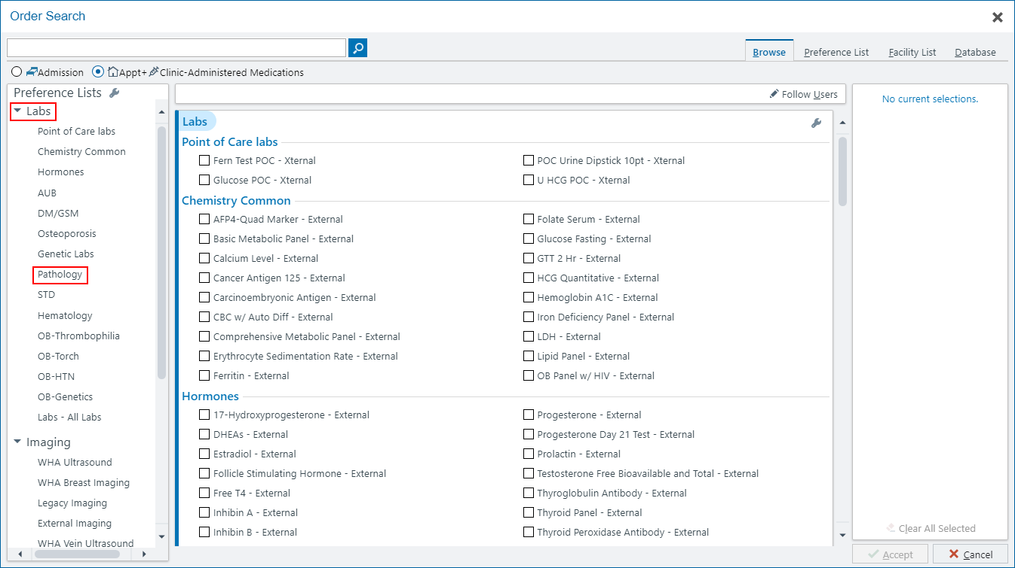
- Select Pap smear with HPV – External.

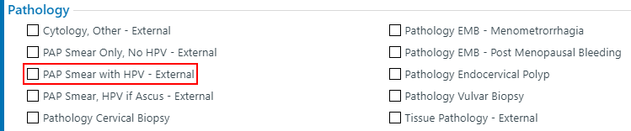

- Click Accept in the bottom right corner of the window.

Notice the Pap Smear Request order has a hard stop next to it. This needs to be resolved before the order can be signed.

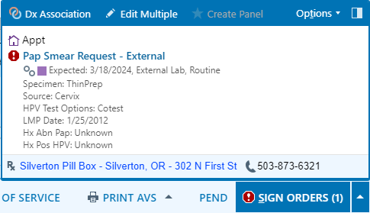

Pap smear orders will automatically pull in information from the patient’s chart, such as a history of abnormal paps and the LMP.

- Click the Pap Smear Request – External order to open the order details.

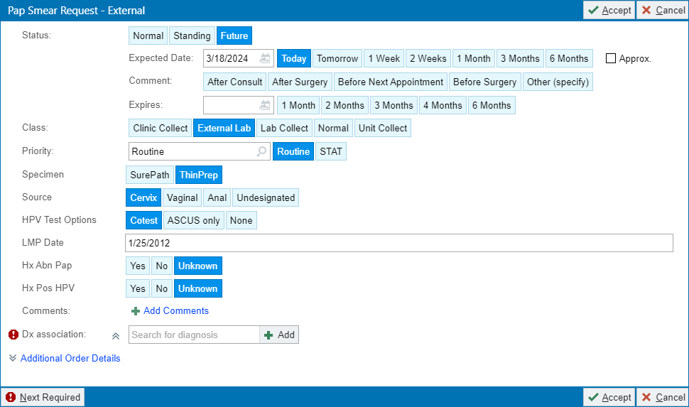

- Review the Source, HPV Test Options, LMP Date, Hx Abn Pap, and Hx Pos HPV sections.
- If everything is accurate, click Accept.
- Click Dx Association.

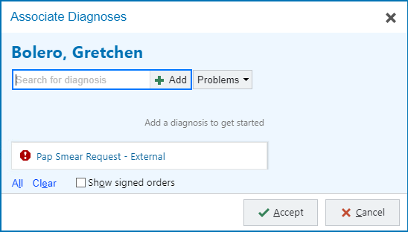

- Search for Cervical cancer screening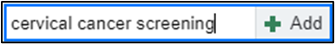 and press Enter.
- Ensure Cervical cancer screening is highlighted.
- Click Accept.

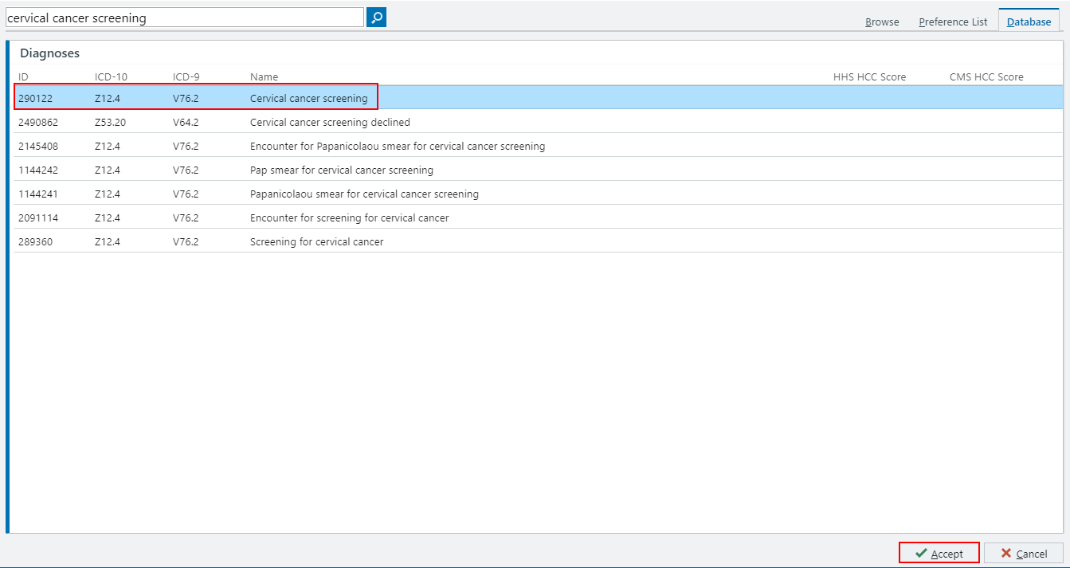

Notice the hard stop next to the pap order is now gone.

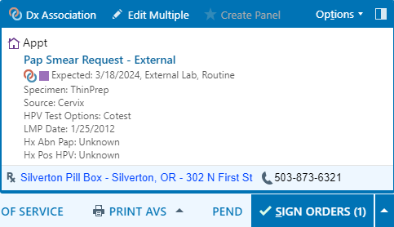

- Click Sign Orders. 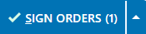

A Providers window opens.
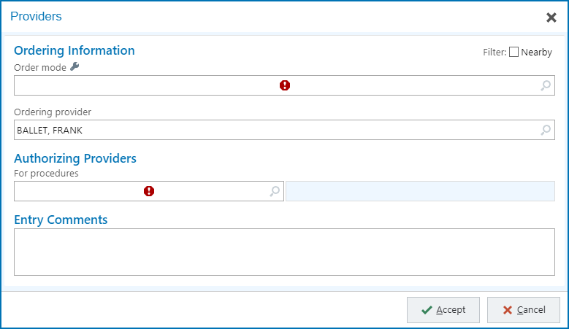

- Enter in Order Mode: AMB, then tab. AMB Scheduled Ord Protocol will auto populate into box.

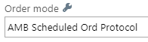
- Document the Ordering and Authorizing Provider, if it does not auto-populate. Use the Frank Provider from your login sheet.

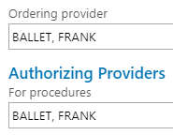
- Click Accept 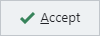

This Visit Activity: 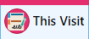

In the right-hand column of This Visit activity is the Patient Instructions, Follow Up, AVS information, Communications, and Charge Capture activities.

- Click on the Patient Instructions.
- Type WHA Stay Healthy in the Insert SmartText box.

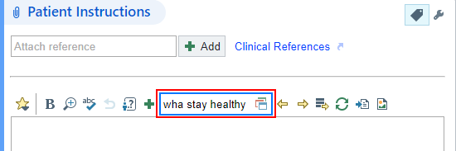

- Make selection based on patient’s age.

- Go to Follow-up.
- Fill in the following information:
Return in: Select 1-years button.
For: A wellness visit.

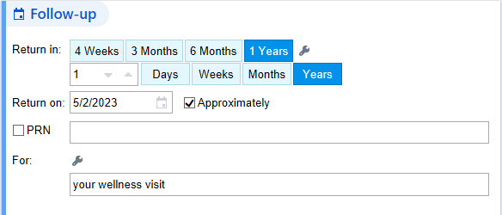

- Go to Level of Service in the visit task bar on the bottom right of the screen. You may select level of service for this appointment type. Patient is established at WHA and is 57 years old.

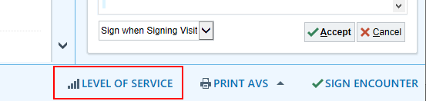
- Locate and select EstPrev40 speed button.
- In the training environment you will need to add an Authorizing Provider:

Use your Frank Provider from your login sheet.

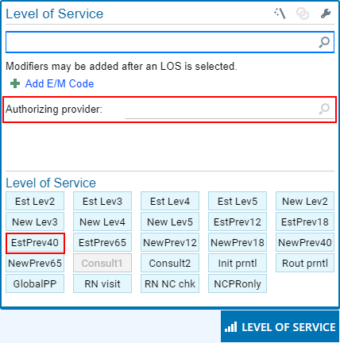

Now you will need to route the Chart to your Trainer. This activity is located at the bottom of the Follow Up activity, below Additional Details.

- At the bottom of the Follow Up activity, locate the Send Chart Upon Closing Workspace section.

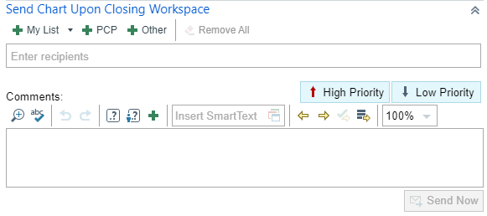

- Enter Stacey Bolero in the Recipients field.
- Click Send Now.

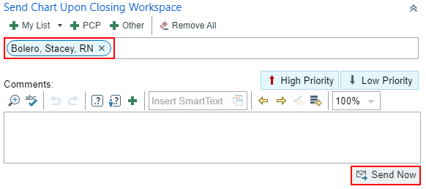

Before leaving the exam room, we need to let the provider know the patient is ready to be seen by the provider.

- Click the Schedule workspace tab.
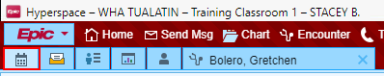

- Change the blue flag dot to the green flag to let the provider know that the patient is “Ready for provider”.

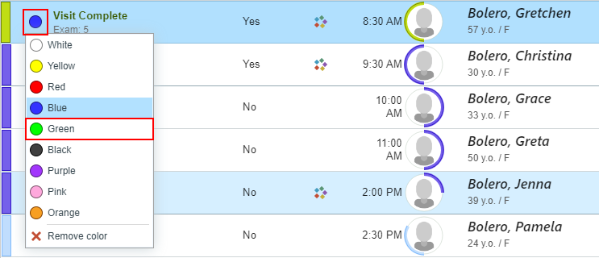

- Then, return to the encounter by clicking the patient’s chart tab at the top of the screen.
- Click secure before leaving the exam room.

Exercise 2: Vaginal Discharge – Gyn Triage

Scenario: Grace is being seen today for a Gyn Triage appointment. She complains of vaginal discharge. Before you pull Grace back, review her Snapshot report in the Preview Report Pane.

Interpreter Documentation Activity:

- Click the Needs Interpreter banner to open the Interpreter Documentation activity.

An Interpreter window opens.

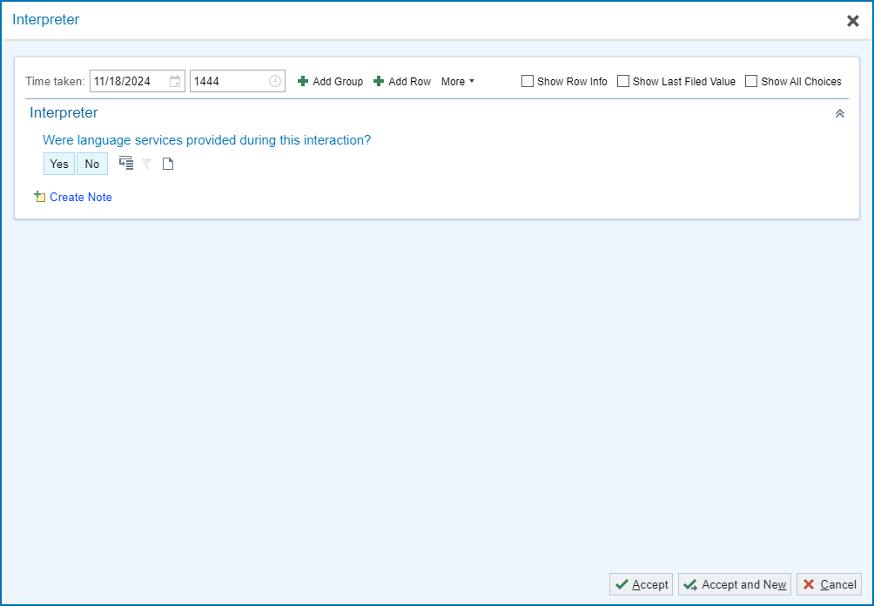

This activity works based on cascading rows , so depending on the answer selected it could trigger more questions. For Grace’s appointment, document that you did use a telephonic interpreter from Linguava named Carrie Smith who is not OHA Certified.

- Were language services provided during this interaction?: Yes.
- Interpreter/Bilingual Staff/Visit provider: Professional Interpreter
- Interpreter/Bilingual Staff/Visit Provider Full Name: Carrie Smith
- Interpreter Mode: By Phone
- Interpreter Service/Agency: Linguava
- Is the interpreter certified or qualified through the Oregon Health Authority? Not Certified /Qualified by OHA.
- Click Accept once documentation is complete.

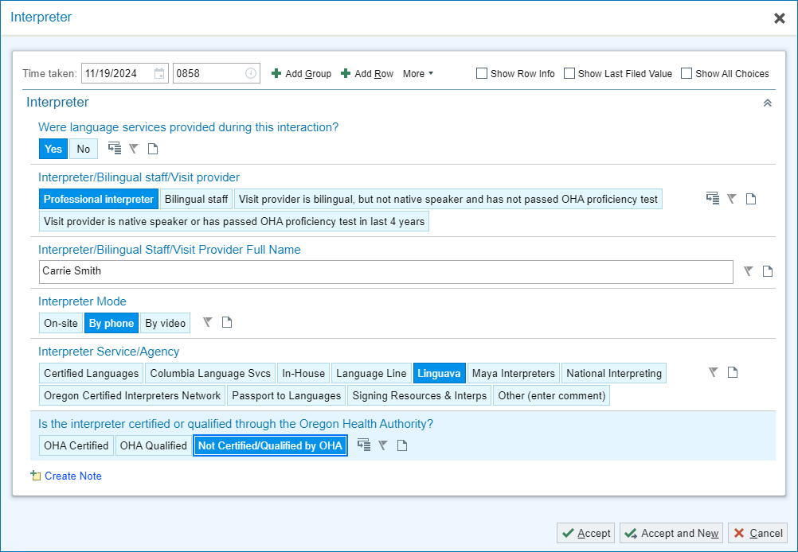

Rooming Activity:

This activity is where you document the “intake” information for the patient.
Document the reason the patient is being seen today.

- Click the Chief Complaint section to open the section.
- Click the speed button: Vaginal Discharge.
- Add a Comment if applicable.
- Click the Close button at the bottom left of the section.

Next, document the vitals that have been taken for the patient.

- BP: 118/78, Site, Position, and Cuff size.
- Heart Rate: 74
- Temperature: 97.6f
- Temp Src: tymp
- Weight: 136lbs
- Height: 67”
- Click the piece of paper to document this [height obtained from prior visit].
- Resp: 15
- Sp02: 99%

For Meaningful Use, verify Grace’s Tobacco Status, which states Never Smoker.

- Click Mark as Reviewed

Update Grace’s OB/GYN Status.

- Pregnancy Status? Not Pregnant
- Menstrual Status: She is currently having periods
- LMP: w-2 (approximate within days)
- Breastfeeding: Not Breastfeeding
- Click Mark as Reviewed
- Click the Close button on the bottom left of the section.

- Click the pencil .

Grace has requested to have a chaperone present for her visit.

- Click the Chaperone Requested button.
- Click Close.

Notice that there is now a yellow banner in the Storyboard to notify the provider that a chaperone has been requested.

Is the patient having any problems with vaginal bleeding or her periods? No.

Grace states that she has a new allergy to Shellfish, so we need to add it to her allergy list.

- Click the pencil.
- In the Add a new agent search box; Type: Shellfish.
- Select SHELLFISH CONTAINING PRODUCTS from the list.
- Add Reactions: Anaphylaxis.
- Click Accept.
- Click Mark as Reviewed button.

You should see Grace’s added shellfish allergy is highlight yellow since it is a severe reaction. It is also highlighted in the Storyboard for easy visualization.
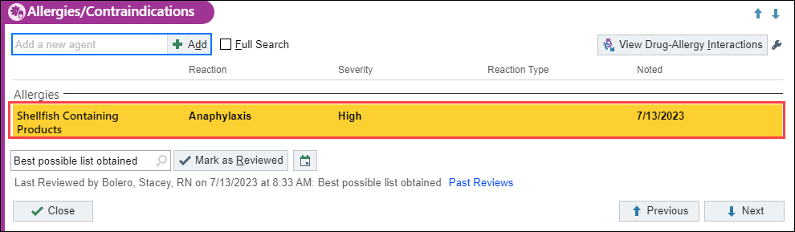

Grace states she is currently taking both of her prescriptions, and that she picks them up at Silverton Pill Box. Mark as appropriate.

- Verify Pharmacy.
- Click Taking on Pepcid and Yaz medications.
  - Or click Mark Unselected Taking to mark all unmarked medications as taking at once.
She states she got an epi-pen for her new allergy to Shellfish. This needs to be added to her medication list.

- Click in the Add Medication box and type: EpiPen
- Press Enter.
- Click EPIPEN 2-PAK 0.3 MG/0.3 ML INJ ATIN.
*Note: Use the Database button for more options if needed.*
- Click Accept.
- Complete the yellow yields for PRN medications
- Mark it as Taking.
- Click Accept.
- Update the Med List Status: click the down arrow and select Best possible list obtained.
- Click Mark as Reviewed.
- Click Close.

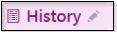

Grace states there are no changes to her histories at this time.

- Click the Mark as Reviewed button at the bottom of the history section.
- Click Close.

Progress Notes Activity: 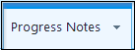

Now you will add a note template.

- Using the drop-down arrow 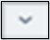 next to the Create Note button, select a template.
- Select the WHA GYN VISIT.
- Place your curser next to History of Present Illness.
- Press Enter.
- Add the smartphrase; .WHAHPIVULVOVAGINITIS
- Press Enter on your keyboard or double click the smartphrase you need.
- Use your clinical judgement to satisfy all the variables and wildcards as if you have Grace in front of you.
- Click Accept when complete.

This Visit: 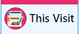

Support staff can add a diagnosis here to support a lab test the provider requests.

- Go to Visit Diagnosis.
- Add vaginal discharge.

Orders Activity: 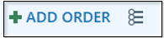

Your provider has given you a verbal order for a Vaginitis Panel. Now, place an order for the test.

- Click the Preference List button.
- Select Vaginitis Panel order
- Click Accept.
- Complete the hard stop.
- Click Sign Order
- Use the Provider window to document orders protocol in the appropriate fields.
- Click Accept.

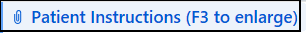
Since this is a problem visit, you will leave this section for the provider to complete.

For this exercise you will leave the follow-up section for the provider to complete. Route the chart to your Trainer.

Send Chart Upon Closing Workspace:
- Enter Stacey Bolero in 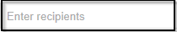
- Click Send Now.
- On the schedule, change the dot to Green to let the provider know that the patient is “Ready for provider”. This is a visual cue for the provider.
- Go back into the patient’s chart.
- Click Secure.

Exercise 3: Dysuria – Established Office Visit

Scenario: Katherine is being seen today for complaints of painful urination. I can see that she has ‘Arrived’ for her appointment, so I will call her back (VERIFY you have the correct patient!), log in to the exam room computer and begin documenting information for the visit.

Double click the patient’s visit to open the encounter for documentation.

Rooming Activity:

- Click the Chief Complaint activity to open the section.
- Use your speed buttons to select Dysuria.
- Click the Close 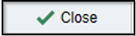 button at the bottom of the section.

Let’s record the vitals you’ve obtained.

- BP: 110/64 then add Site, Position, and Cuff size
- Heart Rate: 88
- Temp: 100.2,
- Temp Src: temporal.
- Weight: 140lbs
- Height: 66i, use the piece of paper to document prior ht.
- Resp: 18
- SpO2: 99

Next, you will document her reported pain levels and location prior to moving on.

- Pain score: patient stated 5.
- Location: Type bladder.
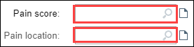

You may choose to use the magnify glass to use the FACES Pain Scale Rating.

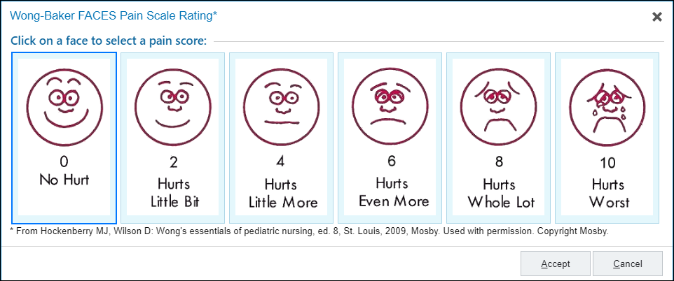

For Meaningful Use, verify Katherine’s Tobacco Status, which states Never Smoker.

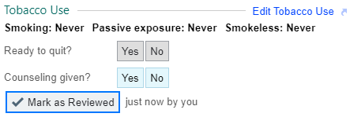

- Click Mark as Reviewed

Update Katherine’s OB/GYN Status

- Pregnancy Status? Not Pregnant.
- Menstrual Status: She is currently having periods.
- LMP: w-2 (approximate within days)
- Breastfeeding: Not Breastfeeding
- Click Mark as Reviewed
- Click the Close button on the bottom left of the section.

- Click the pencil .

Katherine has requested to have a chaperone present for her visit.

- Click the Chaperone Requested button.
- Click Close.

Katherine's issue today is unrelated to her menstrual cycle. There is nothing to do in this activity.

Verify with Katherine that her allergy list is correct and that she is still not allergic to anything. She confirms No Known Drug Allergies (NKDA).

- Click the Mark as Reviewed button.

Katherine states she is not currently taking any medications, but that she picks up her prescriptions at Safeway at 13434 Colton Place in Oregon City, OR.

Notice that her pharmacy is listed as Hermiston Drug and Gift, let’s change it to her updated Safeway Pharmacy.

- Click on the pharmacy hyperlink to open pharmacy search window.

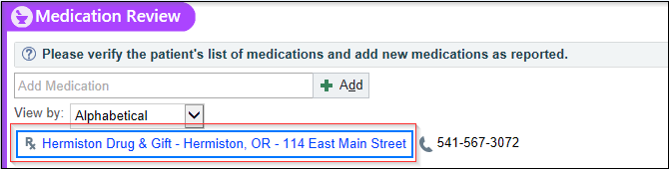

- Click the X to remove the Hermiston Drug & Gift pharmacy.
- Name: Safeway
- City: Oregon City
- Uncheck the box patients and clinics nearby zip codes.
- Click Search. 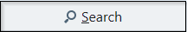
- Star pharmacy to favorite.
- Click Accept.
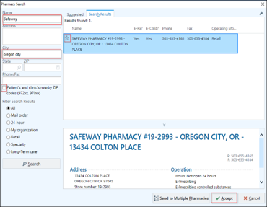

Katherine says she used Pyridium for two days and is no longer taking it.

- To discontinue the Pyridium click the red X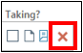 at the far right of the medication name.
- Document an appropriate discontinue reason. Select Therapy Complete.
- Click Accept.
Katherine states she has not had a migraine in 6 months, so has not taken Imitrex but still has it on hand in case of a migraine. Notice the sig mentions this is an as needed medication.
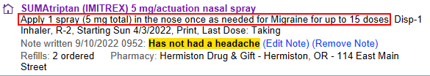

- Click the Taking button.
- Click the Edit Note hyperlink to update the note on the medication.

A Medication Notes window opens.
- In the free space type: Has not had a migraine for 6 months.
- Click Accept.

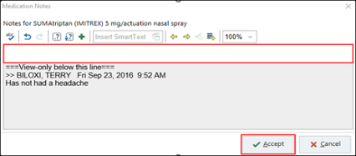

- Update the Med List Status: click the down arrow and select Best possible list obtained.
- Click the Mark as Reviewed button.
- Click Close.

History needs to be reviewed and verified so that we have the correct information documented for meaningful use.

No changes to Katherine’s history currently.
- Click the Mark as Reviewed button at the bottom of the history section.
- Click Close.

Now that you have completed documenting the “intake” for the patient, it is time to continue with the specific scenario.

This Visit:

- Go to Visit Diagnosis.
- In the Search for new diagnosis text box, type: dysuria.
- Press Enter or click on Add 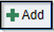.
- Click Accept.

Since Katherine is complaining of dysuria, it is protocol for the support staff to run an in-clinic (point of care or POC) a urine dip on the Clinitek, a urinalysis machine.

Orders Activity:

Now, place an order for a POC U Dipstick.
- Click the Preference List (next to the Add Order) 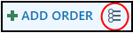 button.
- Click the arrow next to Labs in the Navigator on the left side.
- Click Point of Care (POC), to view those types of orders.

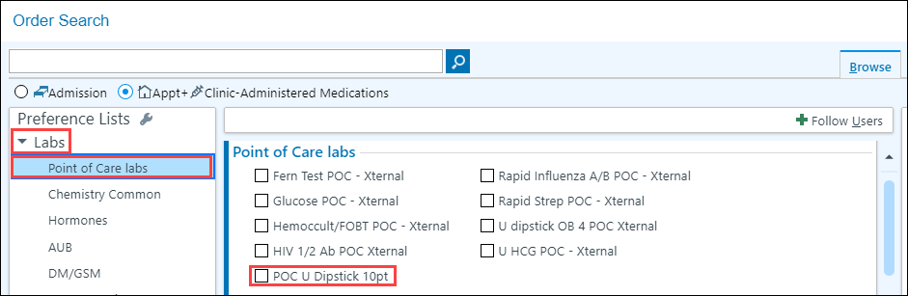

- Select POC U Dipstick 10pt order.
- Click Labs - All Labs.
- Select Culture, Urine - External.

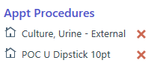

- Click Accept.
- Click on Dx Association.
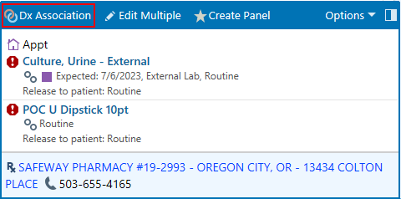

- Section Dysuria.

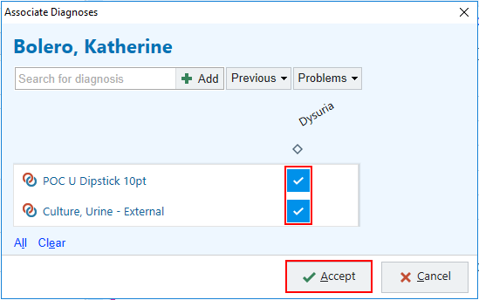

- Click Accept.

Notice the hard stop next to the Urine Culture.

- Click the Urine Culture to open the order.
- Satisfy the hard stops using the options available.

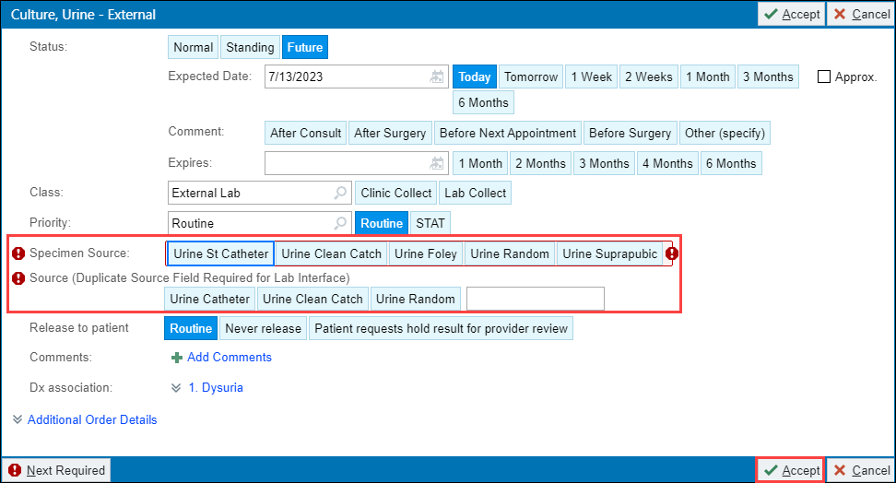

- Click Accept.

At this point, we are unsure if our provider will decide to send the urine culture or not. So, we will only sign the POC order.

- Click the arrow pointing up next to the Sign Orders 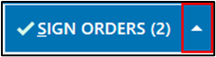button.
- Click Selective Sign.

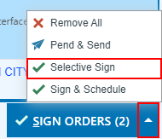

A Selective Signing of Orders box will open.

- Check the box next to the POC dip order.
- Click Accept.
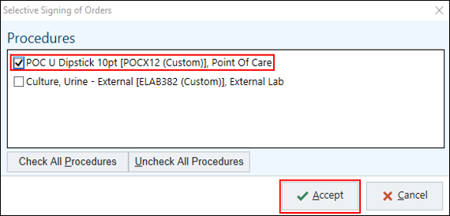

The Provider’s window opens.

- Enter the Order Mode: AMB, then tab. AMB Scheduled Ord Protocol will auto populate into box.
- Document the Ordering and Authorizing Provider, using the Frank provider from your login sheet.
- Click Accept.

You complete the 10-point Dipstick test, and you need to document the results. The POC U Dipstick test has come back with some abnormal results.

Enter/Edit Results Activity: 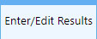

- Click on Enter/Edit Results
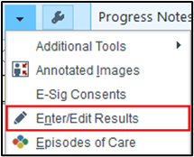
- Double-click the POC Urine Dipstick 10 order.

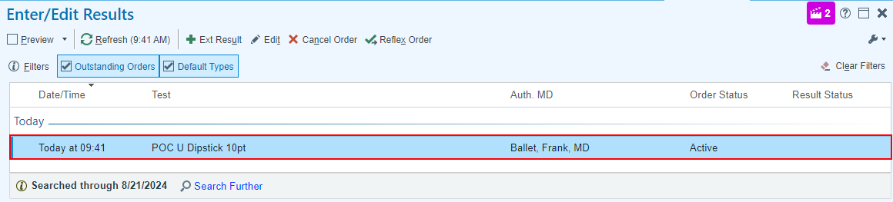

Now you will transcribe the results into the patient’s chart.

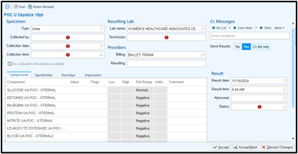

- Collected by: Patient.
- Collection Date: t – for today
- Collection Time: n-15 to document the collection time was 15 minutes ago.
- Lab name: Defaults with Women’s Healthcare Associates.
- Technician: Your initials.
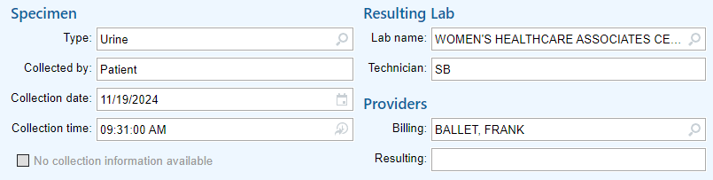

Under the Components tab, complete the required fields below….

- Click into proper box, click the selection tool to populate the available options.
- Protein value: trace
- Leukocyte: 3+
- Blood: Trace
- Color and Turbidity: Straw and cloudy
- All other values normal.

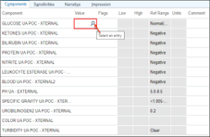

You must complete the last few required fields on the bottom right.

- Verify Abnormal is displayed in the Abnormal box. This feature is automatic when abnormal findings are entered.
- Status: Type F for Final.
- Click Accept located in the bottom right corner of this form.

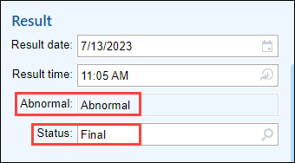

Progress Notes Activity:
- Using the drop-down arrow, select the WHA GYN Visit template.
- Place your curser next to History of Present Illness and press Enter.
- Add smartphrase; .WHAHPIBASICGYN

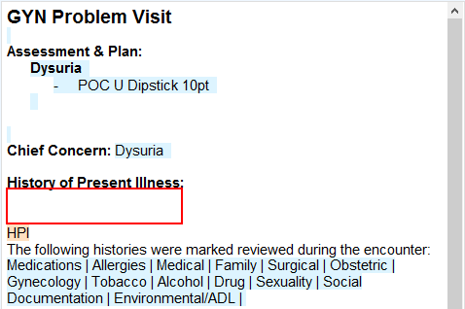

- Press Enter on your keyboard or double click the smartphrase you need.
- Complete the wildcard : type; dysuria.

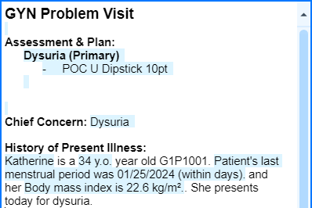

Let’s explore another way in which you can enter HPI information.
- Under you My Note heading; click the HPI 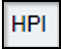 tab.

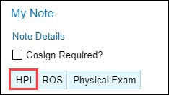

Use the Dysuria form to help guide you through common questions that you may want to review with the patients. If the form does not automatically open, search for Dysuria in the Add an HPI form box.

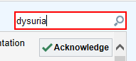

Now practice filling out the dysuria form.

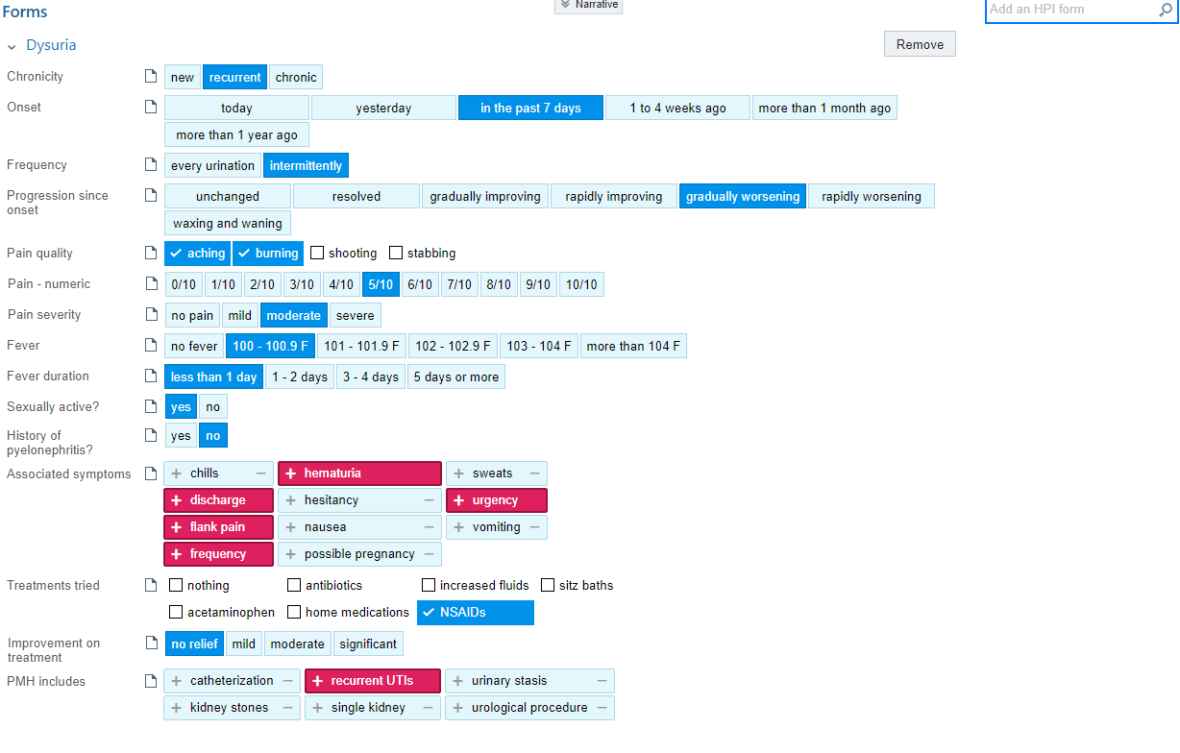

As you click through sections in the Dysuria form, Epic will write a paragraph in the HPI automatically, which has the yellow background in the depiction on the next page.

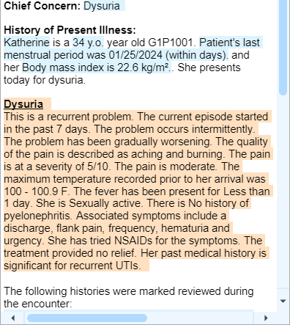

- In the Progress Note under the Dysuria paragraph written by the use of the form, type: .THISVIIST to pull in the results of the urine dip documented in Enter/Edit Results.

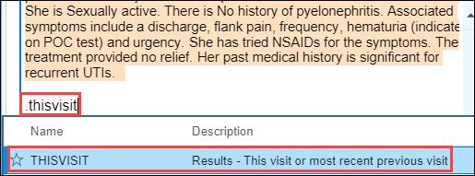
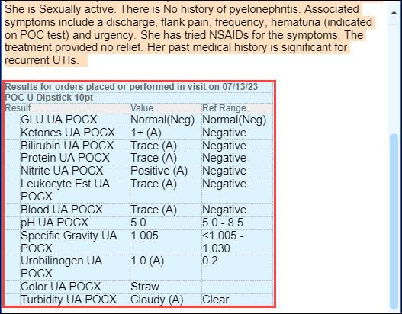

This Visit:

The patient has missed the last few days of work due to her symptoms, and requests that an excuse letter be written for her.

Go to the Communications activity.

- Click New Patient Letter  button
- The Patient auto populates.
- Choose Letter, click on Work/School Excuse.

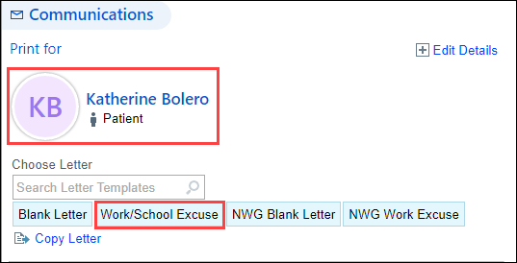

- Use magnifying glass or F3 to make the letter activity bigger.

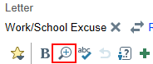

- Complete the Wild cards (***) in the letter using F2 to identify and highlight them.

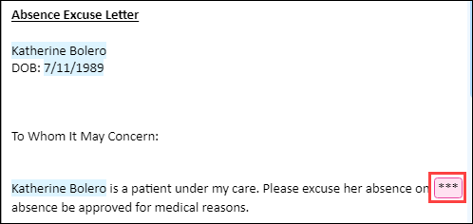
- Add today’s date to satisfy the wild card and replace your name at the bottom with your Frank Provider’s name.
- Click Pend.

You will see the communication saved under Drafts.

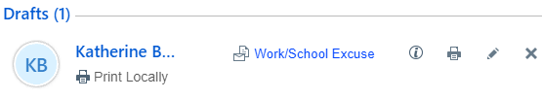

This is a problem visit and therefore you will leave this section for the provider to complete.

Route Chart to Trainer:
- Enter Stacey Bolero in
- Click Send Now

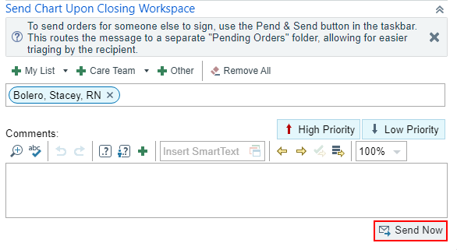

Before leaving the exam room, we need to let the provider know the patient is “Ready to be seen by the provider”.

- On the schedule, change the Blue flag dot to Green flag to let the provider know that the patient is “Ready for provider”. This is a visual cue for the provider.
- Return to the encounter by clicking the patient’s name at the top of the screen, then click on secure before leaving the exam room.

Exercise 4: Pre-Charting Well Woman Exam – WHA Wellness Visit

When the patient’s appointment status has not changed to Arrive and is still displayed as Scheduled, it will allow you to access the visit encounter through a “Pre-Charting” option. This allows you to document ahead and spend more time with the patient.

- Double click on Paula’s chart.

You have limited sections to document, Notice the pre-charting information box. Paula is not Arrived; therefore, you should NOT click start the visit.

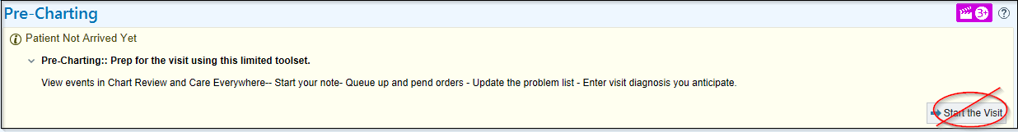

Progress Notes Activity:

- Using the drop-down arrow, Select WHA WELLNESS VISIT template. It will auto-populate information entered into chart.

A Progress Notes box will open.

- In the note, click next to the History of Present Illness title and press Enter.
- Enter the smart phrase .WHAHPIWWE1834
- Only historical information can be added in the Progress Note when you are in a pre-charting status.
- After the statement, “Paula is a 21 y.o. G1P1001 here for her wellness care.” type: She had vaginal delivery on [pick date from 8 weeks ago]. Desires Mirena IUD for contraception.
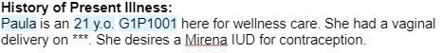
- Utilize the Assistant Bar to search for historical information.
  - Last Pap: Never
  - Due: Today
  - History of abnl: No
- Scroll to the Physical Exam section at the bottom of the note.
- Place your courser next to Physical Exam and press Enter.
- Type; .WHAPROCDOC.

Pre-Charting Activity: 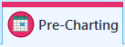

In this section, support staff can add the Visit Diagnosis, Patient Instructions and review the Problem List. The Problem Lists are managed by the providers only.

- Go to Visit Diagnosis.
- In text box, type: Cervical Cancer Screening and select first choice.
- Click Accept.
- Click the blue diamond next to the diagnosis to remove it as the primary diagnosis code.

- Scroll to the Patient Instructions activity.
- Type: WHA Stay Healthy in the Insert SmartText box.
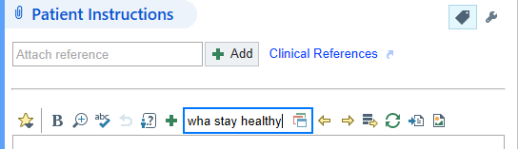
- Make selection based on age.
- After adding these Visit Diagnosis and Patient Instructions, we can add orders for the office visit.
You have finished Pre-Charting and can now exit chart.

Module 3: Other Clinic Visits

Exercise 1: Abnormal Pap Smear – Colposcopy Procedure

Scenario: Greta is being seen today for colposcopy. I can see that she has Arrived for her appointment, so I will call her back (VERIFY it is the correct patient), log in to the exam room computer and begin documenting information for the visit.

- Double click the patient’s visit to open for documentation.

Rooming Activity:

- Click the Chief Complaint activity to open the section.
- Click Abnormal Pap Smear speed button.
- Click the Close button at the bottom left of the section.

- Open the Vital Sign section
- BP: 120/80 then add Site, Position, and Cuff size.
- Heart Rate: 100
- Temp: 98.8
- Temp Src: Tympanic.
- Weight: 158lbs
- Height: 5f 8in, use the piece of paper to document “prior height”.
- SpO2: 99

For Meaningful Use, verify Greta’s Tobacco Status, which states Never Smoker.

- Click Mark as Reviewed

Update Greta’s OB/GYN Status.

- Pregnancy Status? Not Pregnant
- Menstrual Status: She is currently having periods.
- LMP: w-3 (approximate within days)
- Breastfeeding: Not Breastfeeding
- Click Mark as Reviewed.
- Click Close.
- Click the pencil on the Chaperone section.
- Select Chaperone present as part of standard provider workflow button.
- Click Close.

Greta verifies that her allergy list is accurate and Iodine is the only thing she is allergic to.

- Click the Mark as Reviewed button.

Greta states she is currently taking a few medications, and that she picks up her prescriptions at Silverton Pill Box – Silverton, OR.

- Verify the Pharmacy is correct.

Greta has not used ibuprofen for several months, but states that she usually takes 600 mg every 6 hours prn for pain.

- Click Taking button.
- Click the medication to open the details and update accordingly.
- Click Accept.

Greta says that she is still taking OCPs (Oral Contraceptive Pills).

- Click the Taking button.

Greta states she had a migraine last week and used her Sumatriptan prescription.

- Click the Taking button.
- Update the Med List Status: click the down arrow and select Best possible list obtained.
- Click the Mark as Reviewed button.
- Click the Close button on the bottom left of the section.

There are no changes for Greta currently. To save time, leave the section closed and review in a collapsed format.

- Click the Mark as Reviewed button at the bottom of the history activity.

Now that you have completed documenting the “intake” for the patient, it is time to continue with the specific scenario.

Now you will place some orders.

Orders Activity:

- Click the Preference List button.
- Click the arrow next to Labs in the Navigator on the left side.
- Click Point of Care Labs.
- Select: U HCG POC- Xternal
- Click Pathology under the lab section
- Select Pathology Cervical Biopsy order
- Click Accept.
- Add in the Clinical Information: 4/2017 – ASCUS HPV+; 4/2018 – LGSIL; 2/11/2022 – ASCUS HPV 16+
- Specimen source 1: leave blank for now
- Specimen Source 2: leave blank for now
- Click Accept.
- Click the Dx Association button to open the associate diagnosis box.
- Click the Problems drop down to view the patient’s Problem list.
- Click ASCUS with positive high-risk HPV cerv…
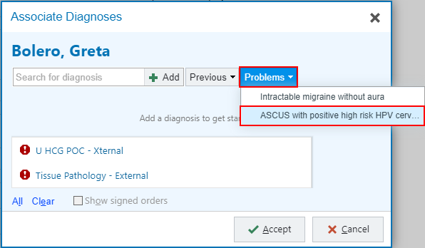
- Click both order boxes to associate with the correct diagnosis.
- Click Accept.

Let’s use Selective Sign to achieve this.

- Click on the more options button next to the Sign Orders button.
- Click on Selective Sign.
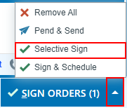
- Click the box for the U HCG.
- Click Accept.
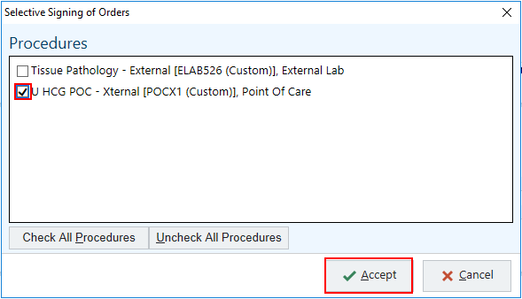

A Providers window opens

- Enter the Order Mode: AMB, then tab. AMB Scheduled Ord Protocol will auto populate into box.
- Document the Ordering and Authorizing Provider (the Frank provider from your login sheet).
- Click Accept.
- Pend the Tissue Pathology order to finish later.

Enter/Edit Results Activity:

Open the Enter/Edit Results Activity.

- Double click the Urine Pregnancy POC test.
- Collected By: Patient
- Collection Date: t in the box and press Tab. This will put today’s date in the box.
- Collection Time: n-10 for the time 10 minutes ago.
- Technician box is where your initials go.
- Value: Negative
- Status: Final.
- Click Accept.

Progress Notes Activity:

- Select the WHA OB/GYN Procedure Note template.
- Add .WHAHPICOLPO under the Assessment & Plan section.
- Complete the variables and wildcards.
- You can use the Assistant Bar and the Patient’s History activity to help find the information you need.
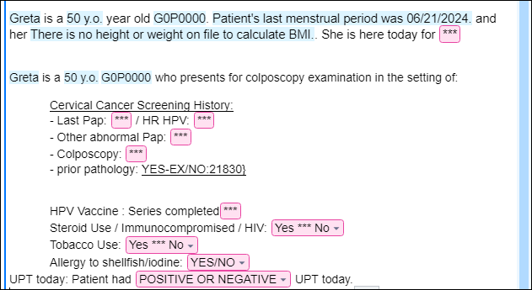
- Add .THISVISITONLY under the Abnormal Pap Smear/Colposcopy Smartphrase.
- Click Procedures tab under My Note.
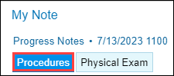

- Change both the Performing and Authorizing Provider boxes to your Frank provider.
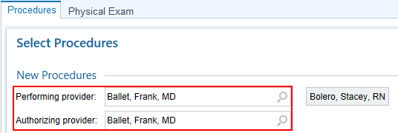
Back Pocket: Use the = key to auto populate your provider’s name under Authorizing Provider.
- Select the Colposcopy button.
- Click Consent to open the consent section.
- Fill in the section after you have the patient sign the consent form.
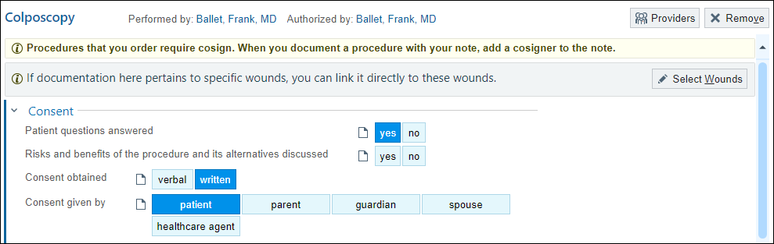
- The Universal Protocol section automatically opens. Click the section header to collapse this.
- The Procedure Location is a Hard Stop and you will not be able to move forward until it is satisfied. Click cervix (This needs to be selected to open the indication section).
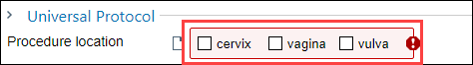
- In the Indication section, choose the results of the patient’s Pap smear.
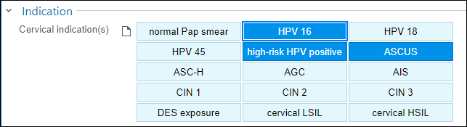

In the History section it showed Greta had an ASCUS, HPV 16 Positive pap.

Your Frank provider discussed the HPV vaccine with the patient who agrees to the vaccine. Let’s create a blank note template to add the SmartPhrase you’ll use to document some vaccine information.

- Click the Create Note button
- Click Create New Note.
- In the blank note; tyle, .WHAHPIINJECTIONDOC
- Click on the SmartList and select Gardasil HPV.
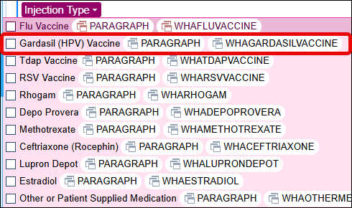
- At the first wildcard, type #1as this will be the first dose the patient is receiving.
You will complete the rest of your documentation after the patient receives their injection.

- Click Accept at the bottom of the Progress Note.

The patient is dressed and prepared for the administration of the first dose. You’ll want to document the vaccine information while in the room with the patient before administering.

Let’s place an order for the HPV Vaccine.

Orders Activity:
- Click the Preference List icon (next to the Add Order).
- Click Immunizations.
- Select HPV Vaccine 9-valent IM
- Click Accept
- Selective-Sign the order.

Immunization/PPD: 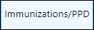
- Click on Immunization activity located under the down arrow in the top right of your screen.
- Click on Administer button.
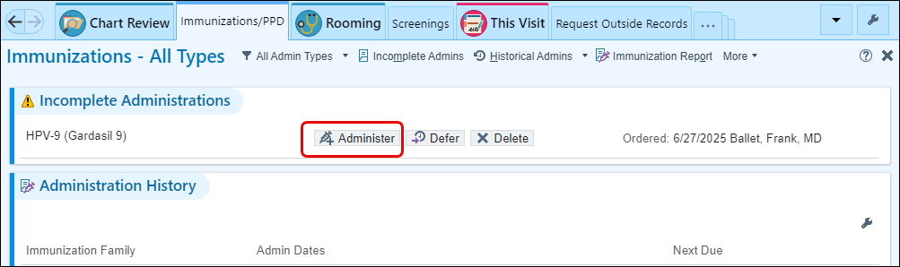
- Lot: X024251
- Site: Right Deltoid
- Click Accept.

Go back to your Note and document how the patient tolerated the injection and when they are due for the next dose.

- Injection Tolerance: select [patient tolerated injection well without adverse reactions.
- Next Injection Due: select the first option on the list and add a date 2 months out.

Now it’s time to prepare after-care instructions for the patient.

This Visit Activity:

We need to give Greta some aftercare instruction for the Colposcopy procedure.

- Go to Patient Instructions.
- In the Insert SmartText box, type: WHA Colposcopy and press Enter.
- A SmartText Lookup box will appear. It will show matches to you search criteria.
- Select the appropriate instructions: LEAP WHA GYN PROC Colposcopy/Cervical Biopsy Instructions.
- Click Accept.
- Go to Follow-up and click the box for PRN. 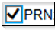

During the procedure, you helped Dr. Frank collect two tissue pathology samples. The first was a cervical biopsy at 1 o’clock, the second was an ECC (Endocervical Curettage). You need to satisfy the hard stops in the Pathology order so it can be signed before taking the samples to the lab for processing.

- Click the 1 Unsigned Order 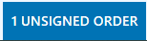 button to see the Pathology Order.
- Click the Pathology Cervical Biopsy order to open the order details page.
- Fill in missing information.
- Specimen source 1: 1 o’clock cervical biopsy
- Specimen Source 2: ECC
- Click Accept.
- Sign the order.

I will now preview the AVS.
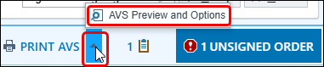
- Click AVS Preview and Options to make changes to the Font Size or language as needed.

Route Chart to Trainer:
- Enter Stacey Bolero in
- Click Send Now

Exercise 2: 8 Week Postpartum Visit with Mirena IUD Insertion – WHA Wellness Visit

Scenario: Paula is being seen today for an 8-week postpartum annual wellness exam. She would also like a Mirena IUD inserted today. She’s checked in for her appointment, so now I can call her back (VERIFY it is the correct patient using 2 patient identifiers), log in to the exam room computer and begin documenting information for the visit.

First, double click the patient’s visit to open for documentation. In Exercise 4, we used the pre-charting feature to prep Paula’s encounter for her visit. Her WHA WELLNESS VISIT note template is already in the Progress Note, the visit diagnosis for cervical cancer screening has been pulled in and her patient instructions were also pulled in.

Rooming Activity:

- Click the Chief Complaint section to open the section.
- Click the speed button: Wellness Visit
- Click the Close.

- Open the Vital Signs section
- Open the Vital Sig BP: 110/74, Site, Position, Cuff size.
- Heart Rate: 66
- Temp: 98.2
- Temp Src: temporal
- Weight: 177lb
- Height: 5f3
- Resp: 14
- SpO2: 99

Update Paula’s OB/GYN Status

- Pregnancy Status. Not Pregnant.
- Menstrual Status: Recent pregnancy.
- LMP: verify with patient as this section populates with pre-pregnancy last menstrual period date
- Breastfeeding: Breastfeeding
- Click Mark as Reviewed.

Verify Paula’s Tobacco Use. She reports that she has recently begun vaping. You will document this information later in the exercise.

Paula has requested to have a chaperone present for her visit.
- Click the pencil .
- Click the Chaperone Requested button.
- Click Close.

Paula had a recent delivery. Therefore, based on whether she has started having periods since delivery, these questions may or may not need to be reviewed. For this exercise, you will document her newly started cycle.

- Click New Reading 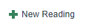 or click on pencil to open section.
- Period Cycle (Days): 29
- Period Duration (Days): 5
- Period Pattern: Regular
- Menstrual Flow: Moderate.
- Menstrual Control: Tampon.
- Menstrual Changes: No.
- Dysmenorrhea: None.
- Click Close.

Verify that Paula’s Allergy list is correct and that she is only allergic to Amoxicillin.

- Click the Mark as Reviewed.
Paula states she is not taking new medications, and she picks up her prescriptions at Hermiston Drug & Gift at 114 East Main St.

- Verify the Pharmacy is correct in chart.
Paula says she is taking her prenatal vitamins.

- Click Taking.
- Med List Status: select Best possible list obtained.
- Mark as Reviewed.
- Click Close.

This review needs to be done once every year.

Obstetric History
- Click the Calculate Counts button to update your G&P.

Medical History
- Search for Depression.
- Click Database
- Double click Depression.

A Details box will open.

- Click the From Patient Questionnaire button.
- Click Accept.
- Add Anxiety and repeat steps to complete.

Gynecology History
- Age at Menarche: 13
- Age at first pregnancy: 20
- Age at first live birth: 21
- Months Breastfeeding: leave this blank as she’s still breastfeeding.

Surgical History
- Add EXTRACTION OF WISDOM TEETH
- Click Bilateral
- Click From Patient Questionnaire button.
- Click Accept.

Family History
- No changes.

Sexual Activity
- Document her sexual activity and contraception, as well as her partner choice of male, female, or both.

Alcohol
- Click Not Currently.

Drug
- Click Never.

Tobacco
- Smoking Status: Some Days.
- In Types select Other and uncheck Cigarettes.
- Change Start Date to two weeks ago by typing W-2 and pressing enter.
- In Passive Exposure, select Current.
- In the Smokeless Tobacco section, select Never.

Vaping
- Update Vaping Use to Current Some Day User by clicking the box.
- Type Less than 1 in the Cartridges/Day box.
- In the Start Date box type w-2 and press enter to pull in the date from 2 weeks ago.
- Choose the type of Vaping Substance and Devices.

Social Documentation
- Verify her marital status, children, occupation, and whether she accepts blood products or not.
- Mark as Reviewed.

Screenings Activity:
For training, you will skip the PHQ9 section.

Progress Notes Activity:

In Module 2: Exercise 4, you pre-charted in Paula’s visit. If there is no prior pre-charting you will need to add the template and Smartphrase.

- Satisfy remaining wildcards by pressing F2.
  - Refills Needed: No
  - Partner Status: Married
  - STD Screening: No
  - HPV Vaccine: No

Notice that the PHQ9 score has not populated. This is because the patient completed this on paper and the information has not been entered.
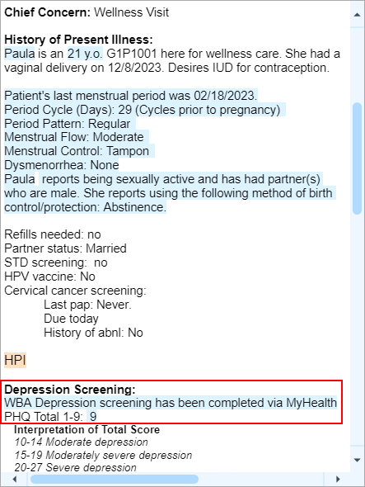
Patient has requested that a Mirena IUD be inserted today. We need to start the procedure documentation for the provider.

- Click into the white space below the orange highlighted text under Physical Exam at the bottom of the note.
- In the white space, type: .procdoc.

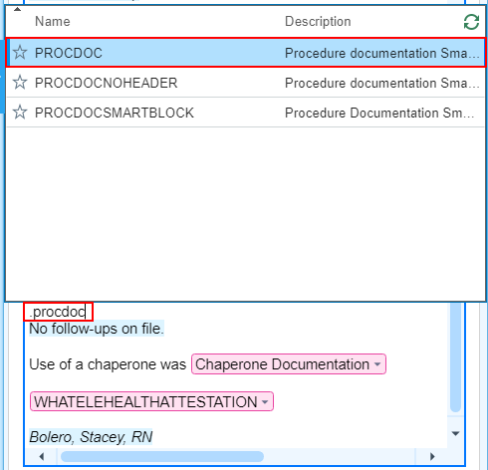

- Using the keyboard, press Enter. The Select Procedures page will automatically populate a list of procedures to choose from.
- Change the Performing and Authorizing Provider to your provider on your login sheet.

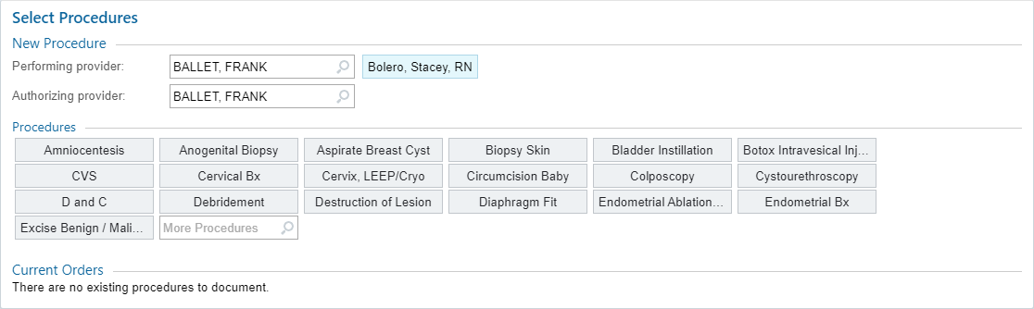

- In the Select Procedures section, find the More Procedures text box.
- Type: IUD.
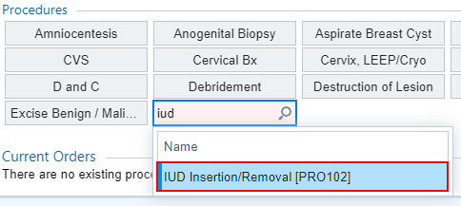
- Press Enter.
- Select IUD Insertion

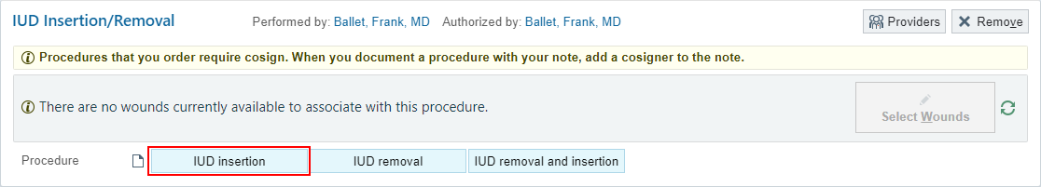

- In the Consent section, click yes.

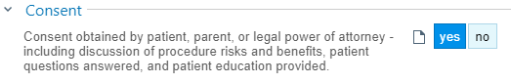

This Visit Activity:



SmartSets is a tool that has predetermined panels where multiple sections can be selected in one location. There is an IUD SmartSet to help standardize IUD visits.

- Scroll down to SmartSets.
- In the Search for new SmartSet box, type: WHA LARC.
- Press Enter.
- Click Open SmartSet
- The information will populate with a checkbox next to it.
- In the SmartSet:
  - The Contraception Chief Complaint checkbox will already be checked for you. Move on to the Orders section.
  - Diagnosis: Encounter for IUD Insertion
  - Orders: UPT (Urine HCG) – POC, Levonorgestrel device (Mirena) and For Med List – Levonorgestrel (Mirena).

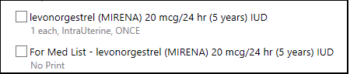

  - Patient Instructions: Mirena FAQ After Insertion
  - Follow-up: PRN
- Click Pend

Pending the SmartSet will add the orders for the Hcg and the IUD to the Unsigned Orders activity. Since Paula is due for a pap smear, we need to add the order. Now, it’s time to satisfy the remaining hard stops and sign everything.

Unsigned Orders Activity: 
- Click the Dx Association.
- Associate each order with the correct diagnosis code.
- Click Accept.
- Click Sign Orders.

A Provider’s window opens.

- Order Mode: AMB, then tab. AMB Scheduled Ord Protocol will auto-populate into box.
- Document the Ordering and Authorizing Provider, if it does not auto-populate use your provider on your login sheet.
- Click Accept.

- Click on the Patient Instructions.
- Type WHA Stay Healthy in the Insert SmartText box.
- Make selection based on patient’s age.

- Scroll to Follow-up.
- Click the 1-year button.
- For: Wellness Visit

MAR Activity: 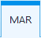

- Click the MAR tab.
  - If you do not see the MAR tab in the activities bar, go to the right and click on the arrow pointing down.
- Click on MAR. It will automatically populate the form.
- Click on the blue bar that says [Time] Due.

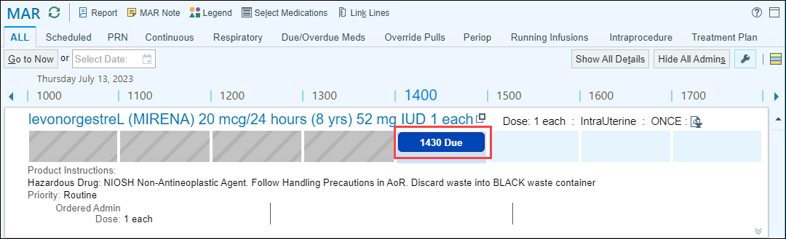

- It will pull you into the medication documentation screen. Go to the Outpatient Billing section and satisfy the hard stops .
  - NDC: Select the magnifying glass. Select the same number as what is on the IUD (for training purposes select the first one). Click Accept.
  - Lot Number: 1234123
  - Expiration Date: y+8 (This will be the date found on the IUD packaging)
  - Billing Provider: Use the Frank provider from your login sheet.
- Click Accept in the lower right corner.

The documentation for this visit is almost complete. We need to make sure that the patient has instructions to review, if needed, after her visit.
- Send the chart to the Trainer (Stacey Bolero).
Before leaving the exam room, we need to let the provider know the patient is “Ready to be seen by the provider”.
- On the schedule, change the Blue flag dot to Green flag to let the provider know that the patient is “Ready for provider”.
- Return to the encounter by clicking the patient’s name at the top of the screen, then click on secure before leaving the exam room.

An Associate Diagnoses window opens.

- Associate the IUD Procedure with the Encounter for IUD Insertion diagnosis code by checking the box.

Exercise 3: Clinic Administered Medication Documentation – Nurse Visit

You will need to switch your schedule view to TN NURSE, WHA for this visit.

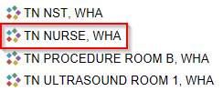

Scenario: Maria has now returned to the office for her lab appointment and has an interpreter with her.

Interpreter Documentation Activity:

- Click the Needs Interpreter banner to open the Interpreter Documentation activity.

An Interpreter window opens.
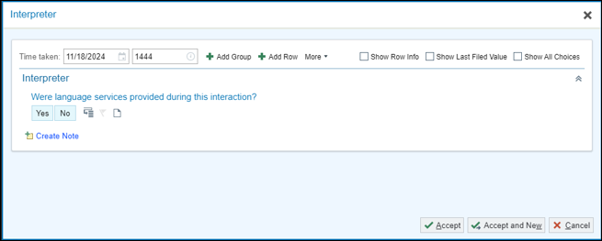

For Grace’s appointment, document that you did use a telephonic interpreter from Linguava named Carrie Smith who is not OHA Certified.

- Were language services provided during this interaction? Yes.
- Interpreter/Bilingual Staff/Visit provider: Professional Interpreter
- Interpreter/Bilingual Staff/Visit Provider Full Name: Carrie Smith
- Interpreter Mode: By Phone
- Interpreter Service/Agency: Linguava
- Is the interpreter certified or qualified through the Oregon Health Authority? Not Certified /Qualified by OHA.
- Click Accept once documentation is complete.

Rooming Activity:

Maria states she is here for a Depo Provera Injection.

- Open Chief Complaint
- Type Depo.
- Press Enter.
- Select Depo, Subsequent.

I will now move on and review the vitals taken today at her earlier visit.

- BP: 110/74 then add Site, Position, and Cuff size
- Heart Rate: 66
- Temp: 98.2
- Temp Src: tymp
- Weight: 123lb
- Height: 5f 3in
  - Height Comment: Prior height
- Resp: 16
- SpO2%: 99
For Meaningful Use, verify Maria’s Tobacco Status.

- Click Mark as Reviewed
Update Maria’s OB/GYN Status

- Pregnancy Status: Not Pregnant
- Menstrual Status: Injection
- LMP: m-6 (6 months ago)
- Approximate: Within Weeks
- Breastfeeding: Not Breastfeeding
- Click Mark as Reviewed.

Will Maria need a sensitive exam for this visit? No.

Your patient has not had a period in 6 months and is not reporting any issues with bleeding. Do you need to update this section? No.

I also need to verify that Maria’s Allergy list is correct and that she is allergic to tree nuts. Maria verifies she does not have any new allergies.

- Click Mark as Reviewed

Verify where she likes to pick up her prescriptions. She reports she’s currently taking all of her medications.

- Patient states she uses the Fred Meyer in Tualatin on Martinazzi Ave for her Pharmacy.
- Mark her medications as Taking, Not Taking, Taking Differently, or Unknown.
- Update Med List Status: Best possible list obtained.
- Click Mark as Reviewed.

Maria states she has no changes to her histories at this time.
- Scroll to the bottom and click Mark as Reviewed.

Progress Note Activity:

You can begin documenting the injection into the note.

- In a blank spot in the Progress Note type .WHAHPIINJECTION
- Press F2 to work through the variables and wild cards available. Utilize the patient’s chart to fill in all the variables.
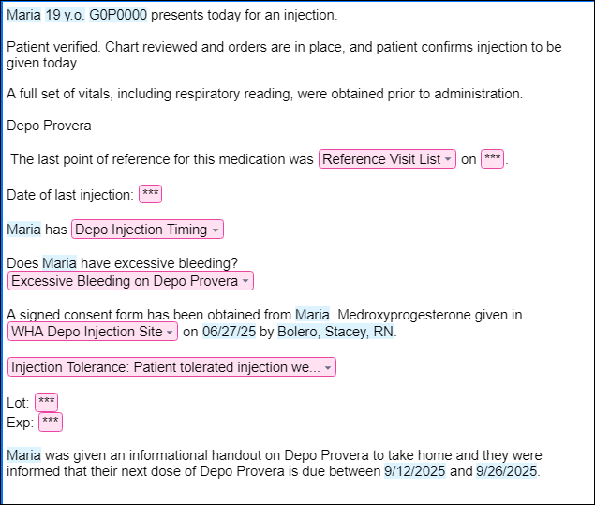

Medication Administration Record (MAR) Activity:

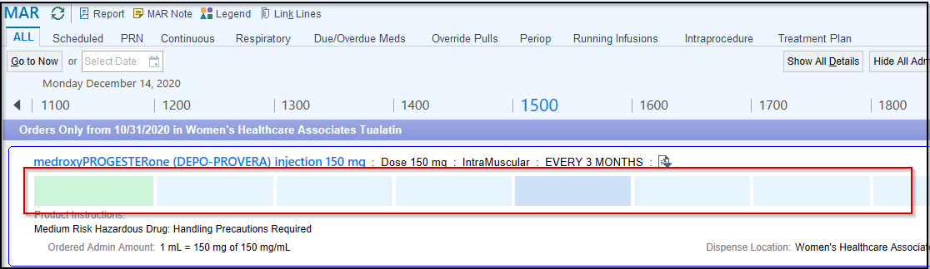

- Click inside one of the boxes to document injection.
- In the Administration Details section the Action box has a hard stop. Satisfy this to move on.
- Click the selection tool to choose from the list.

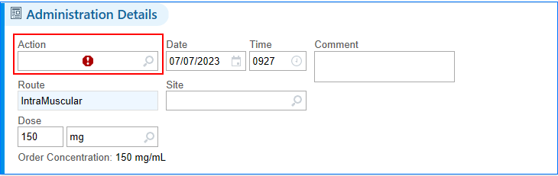

- Select Given.
- A warning box will appear. Click the selection tool and choose Not Given at Scheduled Time.

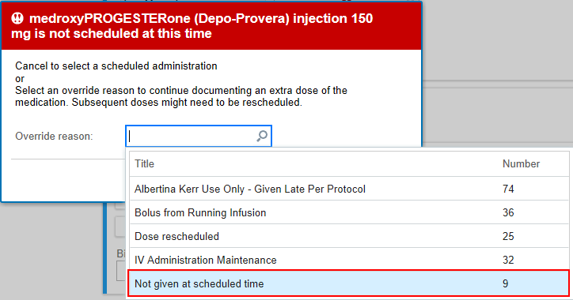
- Click Override. 
- Document the Site: Right Deltoid
- NDC: click selection tool and choose the first option on the list.
- Document the Lot #: 456612A
- Expiration Date: 9/30/2028

This is the point when the injection would be given to the patient.

- Billing Provider: Frank (Authorizing provider on your login sheet)
- Click Accept.
This Visit Activity:

- Go to Visit Diagnosis
- In the Search for new diagnosis text box, type: contraception
- Click Contraception Management if it is not highlighted.
- At the bottom of the Database Matches box will be a Calculator. Select the Contraceptive Type: Injectable

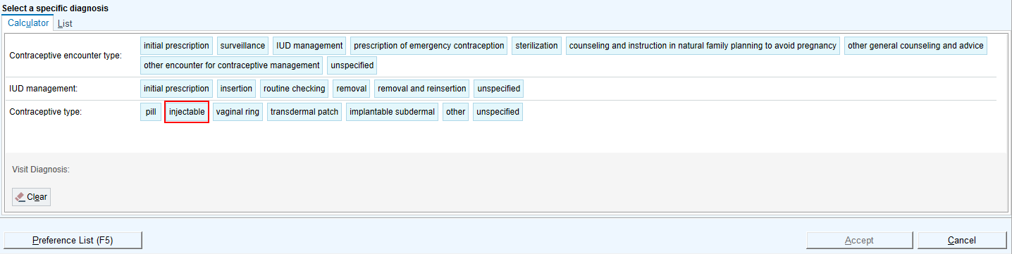

- Select the Contraceptive encounter type: Surveillance.

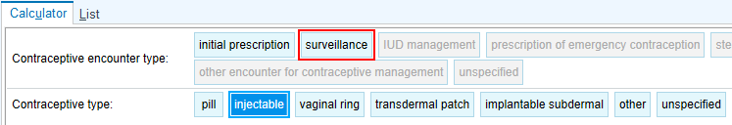

- Click Accept.
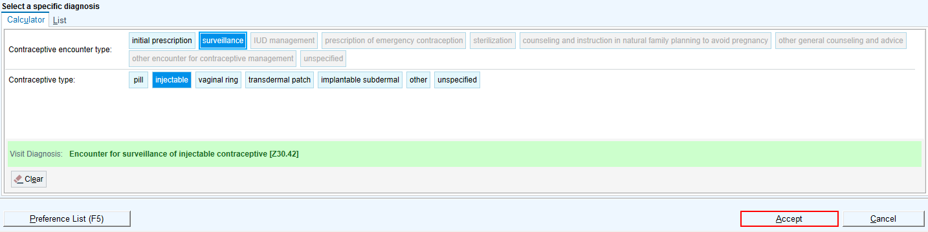

It is time to Wrap Up this visit.

You can use the system to search for visit-related materials that are available. Search for the template for educational materials.

- Go to the Patient Instruction section.
- Click on the Clinical References hyperlink .
- Click in the Search field.
- Type Medroxyprogesterone, then press Enter.
- Click Add in Spanish.
- Select appropriate instructions by checking the box next to it.

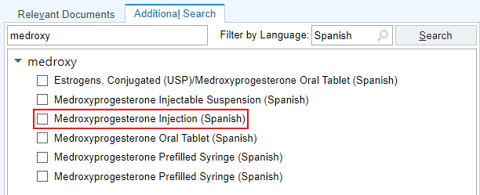

Notice that the instructions are now in the Patient Instructions box as an attachment where you can view, edit, or remove them.
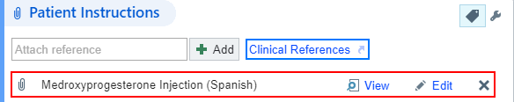

- In the bottom task bar find the LOS field.
- Click the PR NURSE VISIT NO CHARGE button to select that level of service.
- Auth prov field: type in Frank (your provider) and press Enter or try “=” to pull in the same provider.

I would like Maria to come back in 12 weeks for her next Depo Provera injection.

- In the number box, type 12.
- Click Weeks.
- In the For box, type: Depo Provera Injection
- Click the Sign Encounter button.

The Schedule will show her appointment as ‘Signed’

Module 4: Obstetric Clinical Workflows

Exercise 1: 12 Week OB Visit – New OB Workup

Scenario: Christina is coming in for her first visit in person since a positive result from a home pregnancy test. She has arrived for her OB workup.
Take a moment to read through the OB Snapshot report in the Preview Pane.

- Double click on Christina’s chart to open the encounter.

OB Sticky Note Activity: 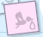
- Click the pink Sticky Note icon to leave a note in the patient’s chart that you and other clinical staff/providers can see.

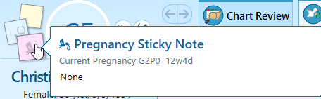

- Type in note.
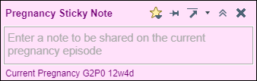

Episode Activity: 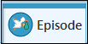
You will notice there are some different activities available for specific documentation in pregnancy.

In the Episode Activity, Christina has an active episode named WHA Pregnancy.

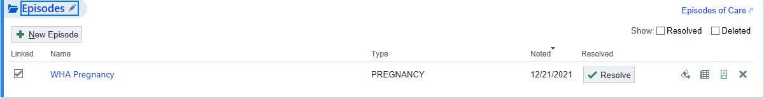



- Search for Traditional or click the Selection tool to open the drop down menu and click Traditional.
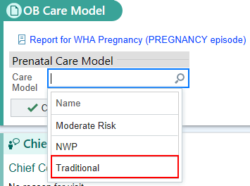

- Click Close.
- Click the Chief Complaint activity to open the section.
- Use your speed button to select Initial Prenatal Visit.
- Click the Close.

- BP: 108/70, Site, Position, and Cuff size
- Heart Rate: 92
- Temp: 98.8
- Temp Src: tymp
- Weight: 156lbs
- Height: 67in
- Resp: 20
- SpO2: 98
Since Christina found out she was pregnant 6 weeks ago, she quit smoking.
- Click the Edit Tobacco Use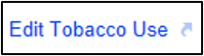 link.
- Verify Smoking Status field: Former Smoker.
- Update the Quit Date field, type w-6.

Notice the OB/Gyn Status section has been updated with the documentation of her LMP and current pregnancy status from the Dating section.

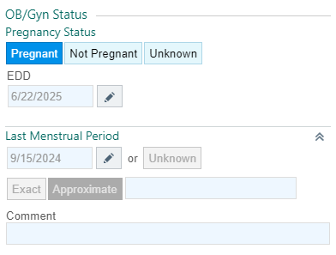

- Breastfeeding: Not Breastfeeding
- Click Mark as Reviewed.

Notice we are now in the History activity; continue to update Christina’s Alcohol and Drug Use.

- Update her Alcohol Use to say Not Currently.
- Update her Drug Use to say Never.
- Click Mark as Reviewed.
- Click the X to close the activity and return to the Vitals activity.
- Click Close to save your documentation in the Vitals activity and move on to the next activity.



For now, we will update what we know about the patient’s pregnancy so far.

- Number of Fetuses: 1
- Support Person: Romeo Montague
- Planned Delivery Location: Meridian Park
- Acceptable Blood Products: All
- Planned Adoption: Not Applicable
- Click Close.

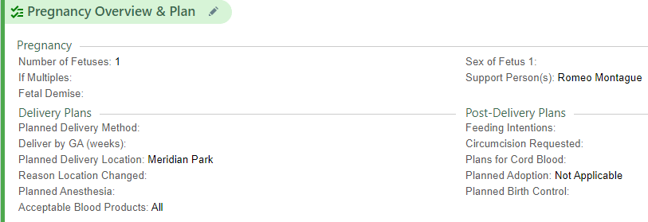

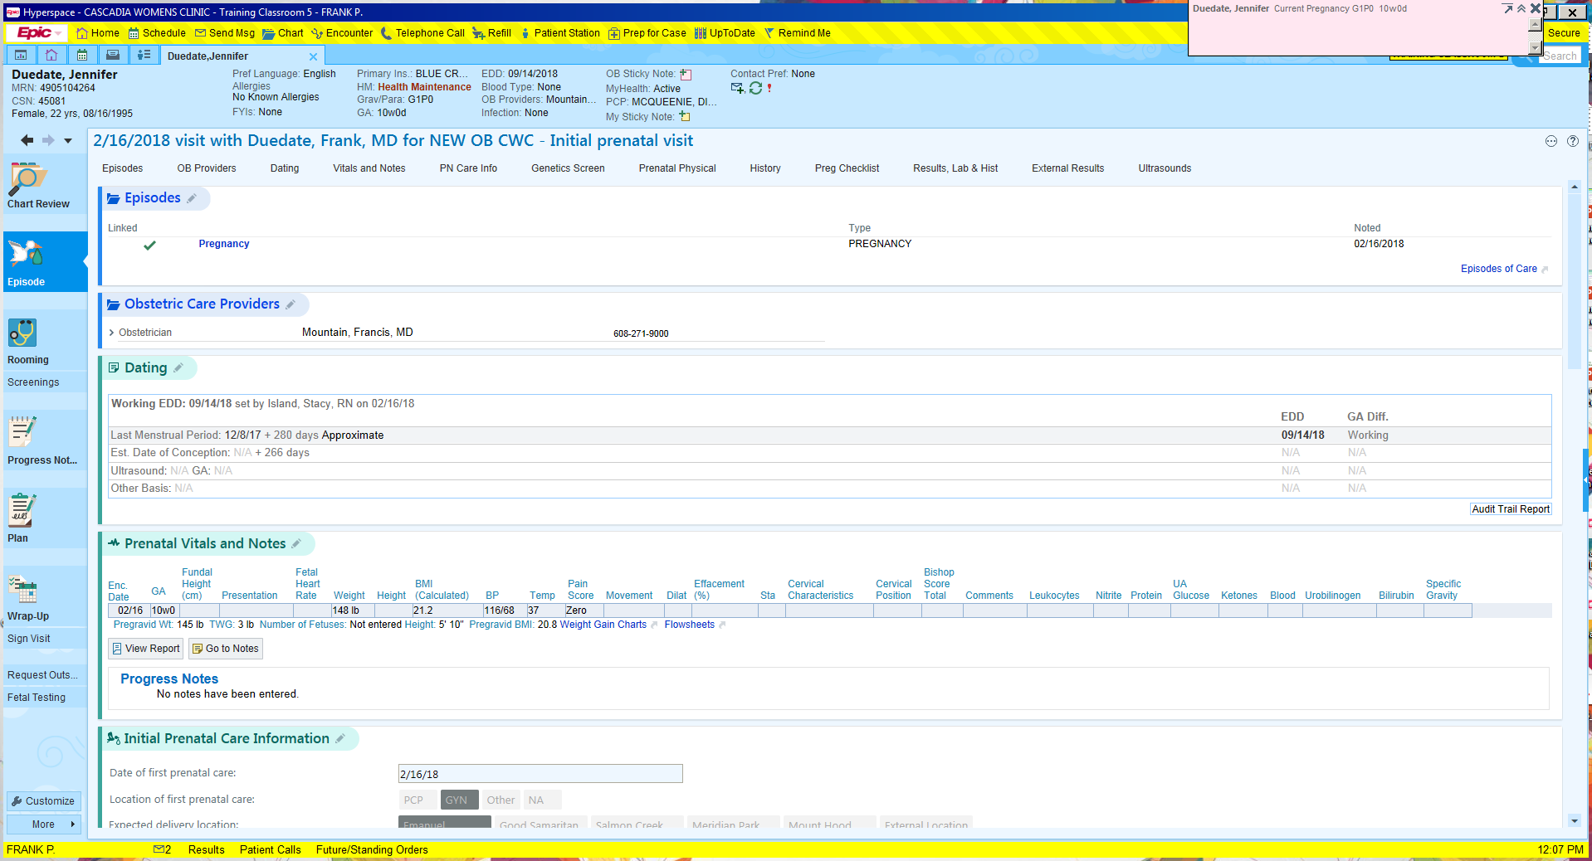

Document Christina’s pre-pregnancy weight, the number of fetuses (if known).

- Pregravid Wt: 145lb
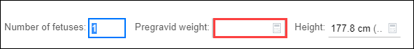

Most New OB Workup appointments will include a sensitive exam, so it is pertinent to discuss this with the patient.

Christina has requested to have a chaperone present for her visit.

- Click the Chaperone Requested button.
- Skip the Post-exam section and click Close.

- Click the Dating section header to open the activity and view the Last Menstrual Period section.
- No information needs to be changed or updated. Click the Close button.

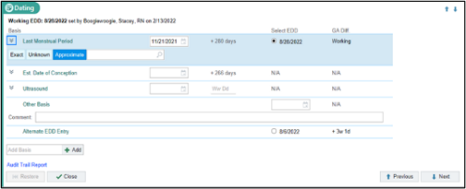
Verify that the Allergy list is correct and that she is not allergic to anything that she is aware of, which she confirms.

- Click the Mark as Reviewed.

First, you notice that she has a pharmacy documented in the system, Fred Meyer on Martinazzi Ave. She states she now goes to Walgreens in Beaverton.

- Click the Pharmacy button
- Click the X next to the Fred Meyer pharmacy to remove it from her preferred pharmacy list.
- In the Name field, type Walgreens
- In the City field, type Beaverton
- Click Search.
- Patient verifies it is on SW Murray Scholls Dr., click the star to add to preference list.
- Click Accept to save the changes.

Verify her medications. She is taking Doxylamine and Prenatal Vitamins already. We need to add Vitamin B6 50 mg as well since Christina takes this as needed for Nausea.

- In the Add Medication field, type Vitamin B6 50 mg and press Enter.
- Select the option Pyridoxine (Vitamin B6) 50 mg oral tab.
- Click Accept.
- Mark all as Taking.
- Update the Med List Status: click the arrow and select, Best possible list obtained.
- Click the Mark as Reviewed.

Christina verifies that she does not have any new medical, surgical, or family medical history.

- Scroll down to locate Social Documentation to make sure it is updated.
- Click Mark as Reviewed.
- Click Close.

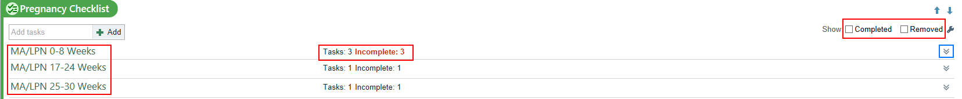

- Using the chevron, open the MA/LPN 0-8 Weeks.
- Review each task with the patient.
- Check the box when complete.

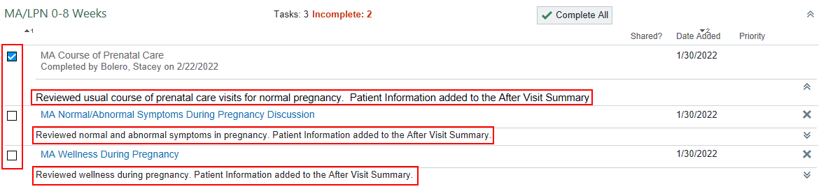

This is the patient’s Edinburgh Depression Scale Score.

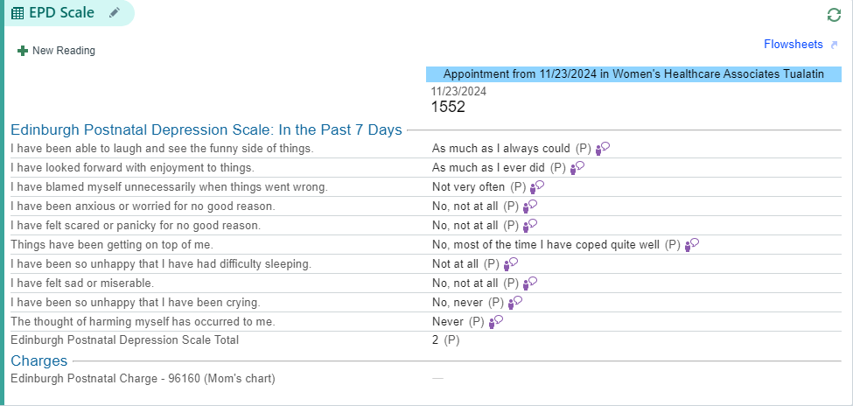

- Click the section name to open it for documentation.
- Ensure the first question is answered. Click No.

- Click the Set all to No button (top right) 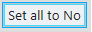
  - If applicable, make any changes before closing the section.

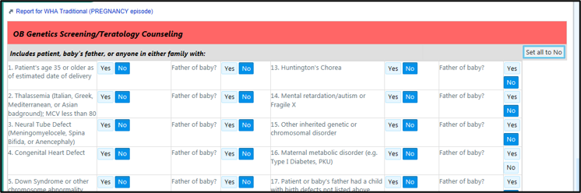

- Indicate whether the patient has completed any health based genetic testing or not, such as genetic cancer panels, 23andMe, or other genetic carrier screening.

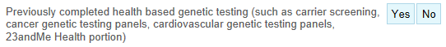

  - If Yes, document in the Details box.
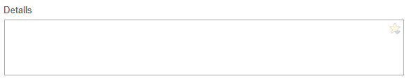

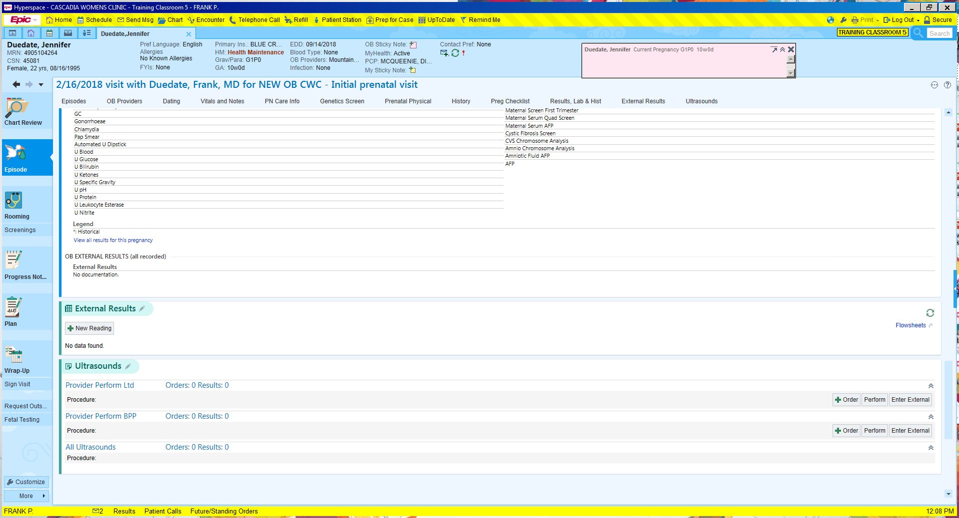

- ClickNew Reading button.

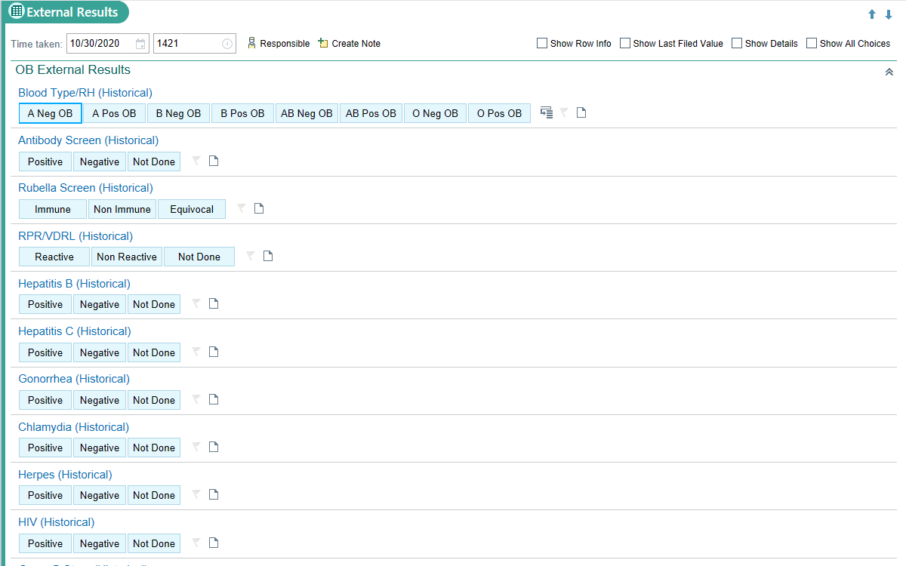
- Result was collected 1 week ago. In the Date field type: w-1.

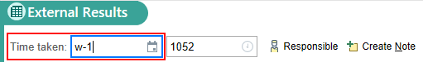

- In the Labs other section, type in HCG – Serum
- Add Comment  of 13,000
- Click Close; repeat as necessary for labs completed on different dates. This ensures the labs will be shown appropriately in the flowsheet.

This Visit Activity:

- Go to the SmartSet section.
- In the Search for new SmartSet box type: WHA OB
- Find WHA OB Care Clinical Staff Rooming SmartSet.
- Right Click on SmartSet.
- Select Add to Favorites.
- Click Accept.
- Click the Open SmartSets button.
- The OB Panel and Chlamydia & GC, TMA orders will be pre-selected. (If another lab is needed simply check the box to include the order.)

Your SmartSet should look like this:

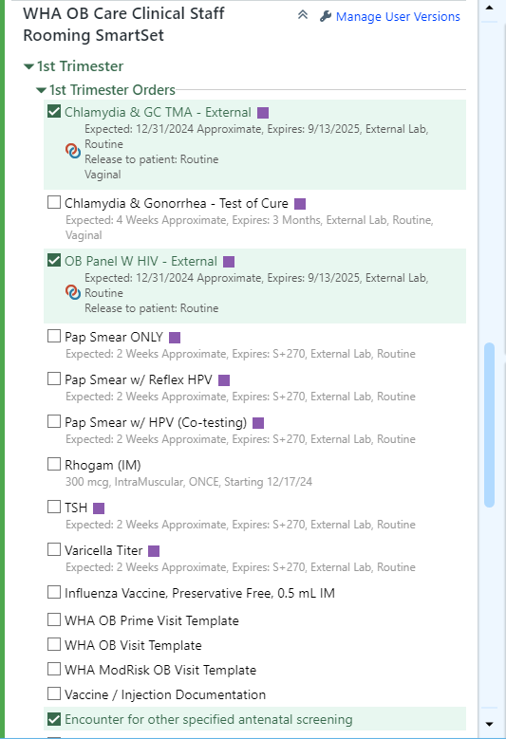
- Scroll to the bottom of the SmartSets activity.
- Select Pend.
- Go to Level of Service on the visit taskbar.
- Select Init prntl.
- Authorizing Provider: enter the provider on your login sheet

Christina needs to come back in 4 weeks for her next appointment.

- Return in: select 4 weeks
- For: Routine OB visit

I will now preview the AVS.

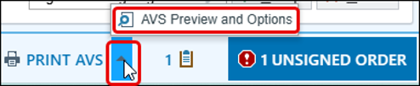

- Click AVS Preview and Options to make changes to the Font Size or language as needed.

Let’s pull in our note template and finish the documentation.

Progress Notes Activity:

Use the templates available to start the note.

- On the far right of your screen, you will see a blue box with an arrow.
- Click on the arrow.
- Go to Create Note and choose the WHA OB Visit template.
- Place your cursor under the starter in the Subjective section but above the HPI smartblock in the Progress Note and press enter.
- Type: .WHAHPIOB12WKVISIT
- Remove any duplicate information in the smartphrase.
- Press F2 to work through the variables to satisfy them.
- Click Accept on the note.

For this training exercise you will order the pap through the Preference list  located in your bottom visit task bar.

- Go to Preference list and add the appropriate pap order for Christina.

Notice in the bottom right-hand corner of the screen that you have 3 Unsigned Orders.

- Click the 3 Unsigned Orders  button to pull up the orders.
- Notice the pap has a hard stop next to it. Click the Pap Smear Request - External order.

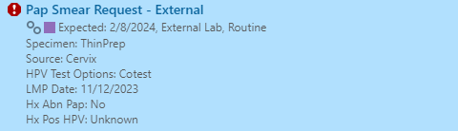

- Verify the patient’s history of HPV to ensure clinical information is accurate. Then, click Accept.

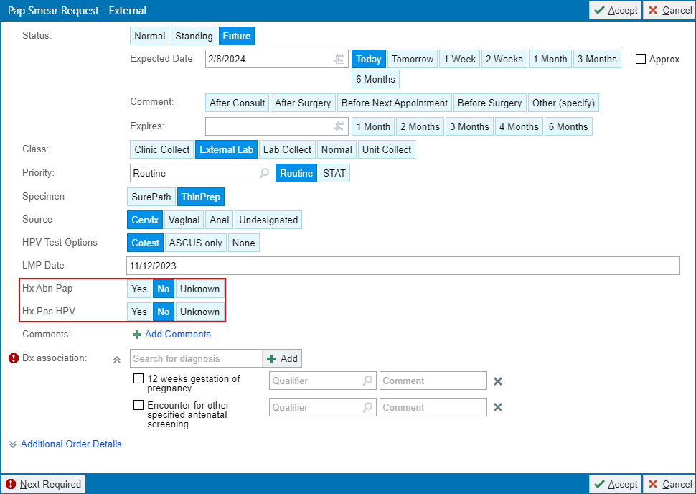

- Click the Dx Association button.
- Add the Cervical cancer screening diagnosis code.
- Check both boxes for cervical cancer screening and HPV screening to associate them with the Pap order.
- Click Sign Orders
- Enter in Order Mode: AMB, then tab. AMB Scheduled Ord Protocol will auto populate into box.
- Document the Ordering and Authorizing Provider, using the provider from your login sheet.
- Click Accept.

Pregnancy Wheel Activity:

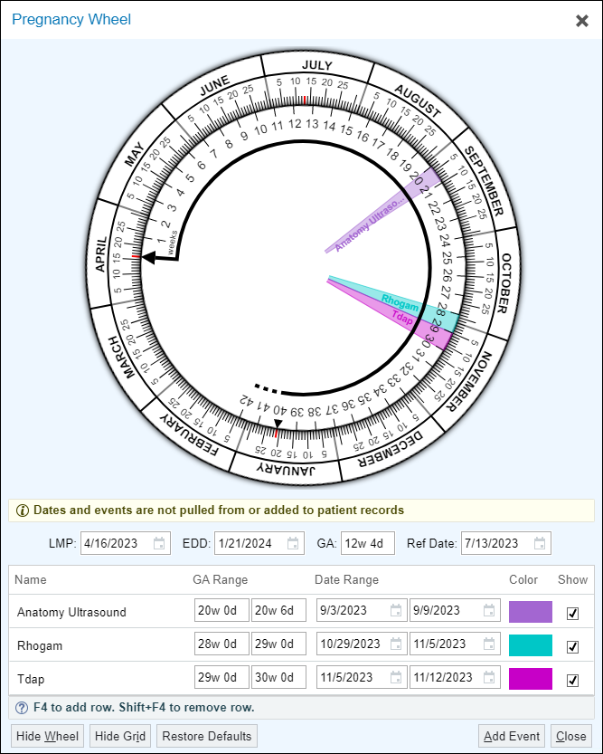

- Click Add Event in the bottom right corner of the window to add things on this wheel.
- Add when the patient will need TDaP, Rhogam, and her Anatomy US.
- Click Add Event button
- Type in Name, GA Range for the event, and click the Show checkbox.
  - Anatomy US – 19w to 20w
  - Rhogam – 28w to 29w
  - TDaP – 28w to 30w
  - Click Close

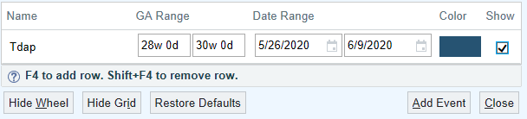

Send chart to trainer:
- Enter Stacey Bolero in
- Click Send Now

Before leaving the exam room, we need to let the provider know the patient is ready for the provider to see them.

- On the schedule, change to a  Green flag.
- Return to the encounter by clicking the patient’s name at the top of the screen, then click Secure before leaving the exam room.

Exercise 2: Return Prenatal Visit/NST Documentation – OB Check w/NST

Scenario: Jenna is here for her routine prenatal appointment. Due to her having a diagnosis of Gestational Diabetes (GDM) and Gestational Hypertension (G-HTN) she is having a Non-Stress Test (NST).

Use some of the reporting tools to get up to speed with your patient.

- Click the OB Snapshot Report in the Preview Report Pane.

Notice, in the Problem List, that she has Pregnancy-Induced Hypertension and Insulin Controlled Gestational Diabetes. Because of these problems, she needs an NST as shown by the Appt Type on the schedule.

- Double click your Jenna patient to open the encounter.

Episode Activity:

- Click the Chief Complaint activity to open the section.
- Select Routine Prenatal Visit.
- Click Close.

- Open the Vital Sign section.
- BP: 146/84, Site, Position and Cuff size,
- Heart Rate: 72
- Temperature: 97.8
- Temp Src: Tympanic
- Weight: 172 lbs
- Height: 64in
- Height Comment: Reading form previous visit.
- Resp: 16
- SpO2: 98
Jenna has requested to have a chaperone present for her visit.

- Click the Chaperone Requested.
- Click Close.



Let’s add to her Pregnancy Overview & Plan.

- Click the Pregnancy and Overview section.
- Pregnancy
  - Number of fetuses: 1
  - Sex of fetus 1: Male.
  - Support Person: Nicholas.
- Delivery Plans
  - Planned Delivery Location: Meridian Park
  - Planned Delivery Method: C-section.
  - Planned Anesthesia: Spinal
  - Acceptable Blood Products: All
- Post-Delivery Plans
  - Feeding Intentions: Breast Milk (This will prompt a BPA in the Plan activity.)
  - Circumcision Requested: No
  - Planned Adoption: Not Applicable
  - Planned Birth Control: IUD-Mirena
- Click Close.

Document the OB urine dip and fetal movement.

- Click the Date of visit hyperlink.

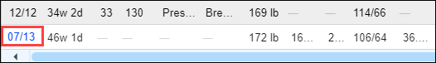
- Fetal Findings - Fetal Movement: Present

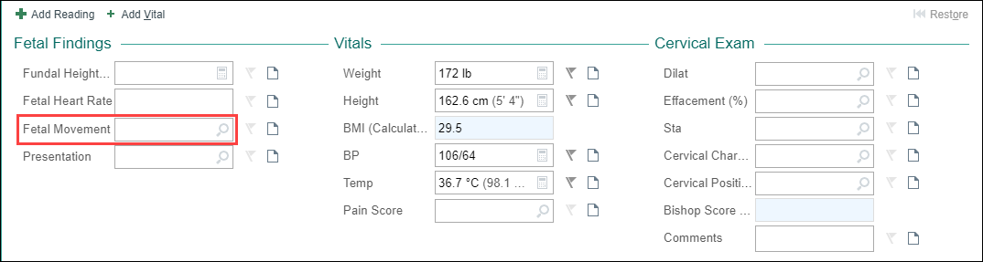

- UA - Protein: 1+ (30)
- UA - Glucose: Normal

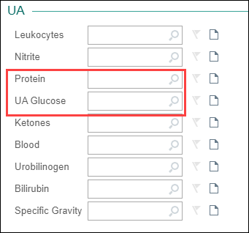

- Click Accept.

Ensure there are no incomplete tasks in the MA/LPN portion of the Pregnancy Checklist.

Verify with Jenna that her allergy list is correct and that she is allergic to Amoxicillin. This is significant information because it will be a question on the order for Group B Strep.

- Click the Mark as Reviewed button.

Jenna states she is still taking aspirin 81mg, Lovenox 150 mg, ferrous sulfate 325 mg, and Prenatal Vitamins. She still picks up her prescriptions at Rite Aid on Barnes Rd.

- Open Medication Review section.
- Verify the Pharmacy is correct.
- Mark Taking or click Mark Unselected Taking on all current medications.
- Remove any duplicates.
- Update the Med List Status: click the arrow and select Best possible list obtained.
- Click the Mark as Reviewed.
- Click Close.

Progress Notes Activity:

- Create Note .
- Select OB Visit. It will auto-populate information entered into chart.

This Visit Activity:

You can view Jenna’s OurPractice Advisories that populate as needed from the Pregnancy Checklist and the Overview and Plan.

- Click Accept to place an order for a Breast Pump.

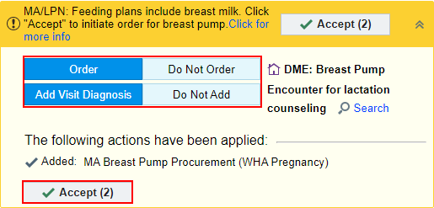

- Go to the SmartSet section.
- Check the WHA OB Care Clinical Staff Rooming SmartSet under your favorites.
- Click on Open SmartSets.
- In the 3rd Trimester Orders section select the Strep Group B PCR – External order.
  - This will automatically select Antenatal screening for streptococcus B as a diagnostic code to be associated with the order.
- Scroll down to the Patient Information (AVS) section.
- Check the BreastPump box.

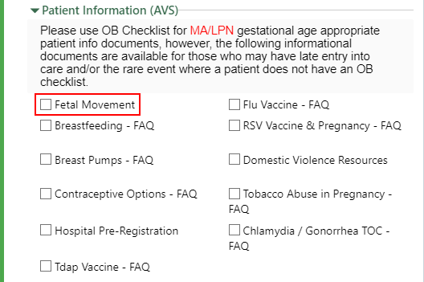

- Click Next at the bottom of the form.
- An order details window will open for the GBS order. To satisfy the hard stop click Allergic to Penicillin.
- Click Accept.
- At the bottom of the SmartSet click Sign.

A Providers window opens.
- Satisfy the hard stops and click Accept.

Now, it’s time to wrap up the visit.

You can now see the Breast Pump information in the Patient Instructions section.
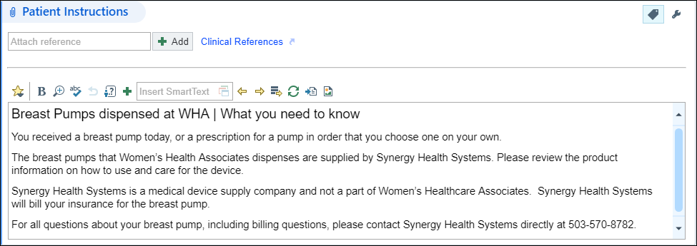
- Select Rout prntl from Level of Service
- Add your Frank Provider as the authorizing provider.

Jenna needs to come back in 1 week for her next appointment.

- Go to the Follow-up section.
- Return in: select 1 week
- For: Routine OB visit

Due to Jenna having gestational diabetes and pregnancy-induced hypertension, you know an NST needs to be completed prior to the provider coming in the room with the patient. Non-Stress Tests are documented in the Fetal Testing activity.

Fetal Testing Activity: 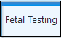

Navigate to the Fetal Testing activity and document a New Reading. The Charges $ will drop when the provider results the NST as reactive or non-reactive.



- Click New Reading button.

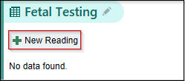

Document your NST (the extent of documentation is dependent on your clinical site and experience)

**Note: You must at least add the clinical reason for the NST as well as the stop and start time.**

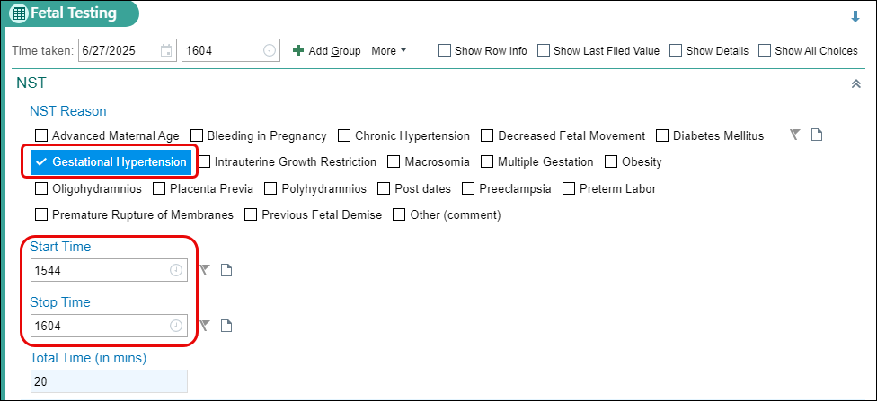

- Check the Gestational Hypertension box.
- Start Time: n-20
- Stop Time: n

Progress Notes Activity:

You can now refresh the Note to add in the NST documentation.
- Click the Refresh icon within the OB template.

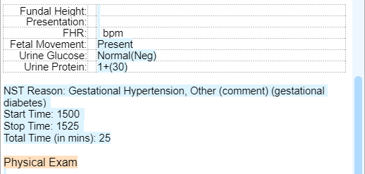
Before leaving the exam room, we need to let the provider know the patient is ready for the provider to see them.

- Send the chart to your trainer Stacey Bolero.
- Change to a Green flag on your schedule.

Exercise 3: 3 Week Postpartum Visit

Scenario: Pamela is being seen for her 3-week postpartum visit.

Chart Review Activity:

Review the 1-week Postpartum Telephone Encounter and her admission to the Midwifery Birth Center (including the Delivery Note). Document any important or pertinent information into the note.

Double Click on Pamela’s appointment to open the Encounter.

Let’s start the rooming process.

Episode Activity:

- Go to Vital Signs.
- BP: 116/74 on Left Arm in the Sitting position using an Adult cuff.
- Heart Rate: 78
- Temp: 98.6
- Weight: 160lbs
- Height: 5’3in
- Document in the comment section “obtained from prior visit”
- Resp: 17
- SpO2: 97

Verify Pamela’s Tobacco Use

- Verify status with patient.
- Click Mark as Reviewed.
Update Pamela’s OB/GYN Status

- Pregnancy Status: Not Pregnant
- Menstrual Status: Recent Pregnancy.
- LMP: Auto populates from LMP prior to pregnancy.
- Breastfeeding: Breastfeeding
- Click Mark as Reviewed
- Click Close.

Since Pamela is a Postpartum Patient, we must enter information into the Postpartum Info section of her chart. This will also pull discrete data into the note.



- Click New Reading
- Ask Pamela the following questions over the phone:
  - Baby Name: Delphina
  - Baby Weight: 7lb 3oz
  - Delivery Date: [insert date from her L&D Delivery Note]
  - Delivery Method: Vaginal, Forceps
  - Feeding Method: Breast
  - Lactation Visit: Yes
  - Lochia Amount: Small
  - Voiding: Normal
  - Stools: Normal
  - Intercourse: No
  - Hemorrhoids: None
  - Incisions: Laceration
    - Comment: 1st degree perineal
  - Current Contraception: Abstinence
- Click Close
- Scroll down to the EPD Scale section.
- Satisfy screening questions.

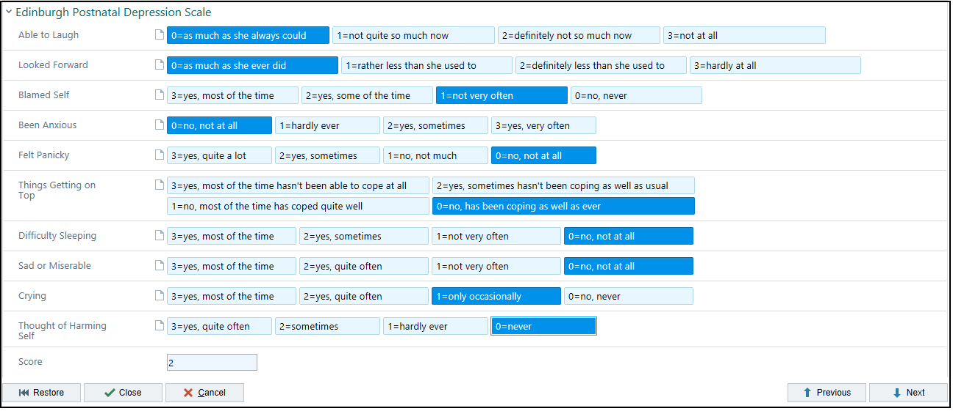
- Click Close 

Notice some activities are not available in the Episode tab. Pamela is postpartum so some things will need to be documented in the rooming tab.

Rooming Activity:

- Click the Chief Complaint to open the section.
- Click the Post-Partum Care speed button.
- Select Close.

Verify that Pamela’s Allergy list is correct and that she is allergic to Cephalosporins and had no additional allergies.

- Click the Mark as Reviewed.

Pamela states she is taking her medication, and that she picks up her prescriptions at Hermiston Drug & Gift – Hermiston, OR – 114 East Main Street.

- Verify the Pharmacy is correct
- Verify that Pamela is taking the Colace, Ibuprofen, and prenatal vitamins and mark as Taking.
- Verify that Pamela is still using her Breast Pump and mark as Taking.
- Update the Med List Status: click the arrow and select, Best possible list obtained.
- Click the Mark as Reviewed.
- Click Close.

No changes for Pamela in her History section at this time.

- Click Mark as Reviewed.
- Click Close.
Progress Notes Activity:

- Create Note.
- Select WHA OB POSTPARTUM.
- Place your curser next to History of Present Illness and press Enter.
- Add the following SmartPhrase: .WHAHPIPOSTPARTUM3
- Satisfy any variables/wildcards and complete your documentation.

This Visit Activity:

Nothing needs to be completed in the Visit Diagnosis section as we are not placing any orders.

- Select the GlobalPP button to choose that level of service.
- Add the patient’s provider to the Auth prov box.

- Have the patient return in 5 weeks for an 8-week postpartum visit and annual exam.

Send chart to trainer:

Let the provider know that she’s ready by changing the colored dot.

Module 5: Wrap Up

Tip sheets
The most up-to-date WHA workflows and tip sheets can be accessed on SharePoint. Click here to go to the Training page to locate the Clinical Services tip sheets.

Where to Find Additional Epic Resources
- Help [F1]: Back Office Learning Homepage
  - What’s New for Back Office?
  - Additional Resources
- Where to find Legacy Connect Resources
  - Dashboards > Legacy Connect User Dashboard >
    - EHR Tip Sheets
    - EHR Support
    - Login Issues
    - E+ Training

